An econometric analysis of the COVID-19 pandemic

on the Caribbean tourism industry

CSEC 491: Senior Project Report

Andrei Pascu

Advisor: Dr. Kim Blenman

May 4, 2023

Table of Contents

Section I. Introduction 4

Background 4

Project Description 4

Section II. Development Environment 7

Project Resources 7

Software Installation 8

Downloading the Project Files 9

Walkthrough of the Repository 11

COVID-19 Data 11

Tourism Data 16

Analysis Code 18

Section III. Individual Caribbean Country Analysis 22

Antigua and Barbuda 26

Aruba 28

Bahamas 29

Barbados 31

Bonaire, St. Eustatius and Saba 32

British Virgin Islands 33

Cayman Islands 34

Cuba 35

Dominica 39

Dominican Republic 40

Grenada 41

Haiti 42

Jamaica 43

Martinique 44

Montserrat 45

Puerto Rico 46

St. Kitts and Nevis 47

St. Lucia 48

St. Vincent and the Grenadines 48

St. Maarten 49

Turks and Caicos 52

U.S. Virgin Islands 52

Section IV. Caribbean Panel Data Analysis 54

Addendum: Economic Impact of COVID-19 on Caribbean Countries 58

# Section I. Introduction

## Background

The COVID-19 pandemic had a profound and long-lasting impact on the economies of the world. One of the industries that was substantially affected by the pandemic is the tourism sector. The number of flights or cruises to tourist destinations plummeted. The introduction of quarantine restrictions aggressively limited incoming visitors and prohibited many recreational activities. A large proportion of jobs in tourism were put on hold and in many cases were terminated. As highlighted by the International Monetary Fund, tourism-dependent regions were most notably and severely impacted by the COVID-19 outbreak and “will likely feel the negative impacts of the crisis for much longer than other economies[1].” One such case study is that of the Caribbean countries, which have a high economic reliance on tourism and thereby have been especially susceptible to the negative financial consequences of the COVID-19 outbreak. Therefore, studying the impact of the COVID-19 pandemic on the Caribbean economy represents an opportunity to analyze the immediate and long-term effects of a health crisis on similar tourism-dependent regions and may help shape predictions about how future pandemic events will affect tourism.

## Project Description

This project seeks to investigate the impact of the COVID-19 pandemic on the tourism industry in the context of the Caribbean region. This senior project is divided into two main parts—an econometric-driven analysis and a software development component—that fulfills the Computer Science and Economics requirements of the CSEC 491 senior thesis course. First, through the investigation of the real-world data, we wish to quantitatively identify the economic effects of the COVID-19 outbreak on the tourist-dependent Caribbean economy. We analyze key economic metrics pertinent to tourism, such as number of visitors, changes in revenue, duration (e.g., overnight; same-day) and mode of travel (e.g., flight; cruise) that we expect to be timely correlated with the onset of the COVID-19 pandemic. Finally, we attempt to estimate the direct impact of COVID-19 cases, deaths and mortality on the Caribbean economy in order to better understand the financial impact of the COVID-19 pandemic on the tourism industry.

Second, using the results from the previous section, we wish to formulate a predictive estimate for future changes in key economic variables associated with COVID-19 rates, leveraging the results found in the first part of this project. The objective is to generalize our findings of the impact of COVID-19 on the tourism-dependent Caribbean economy to other countries that have a similarly heavy reliance on tourism for the growth and generation of tourism volume and revenue. We wish to present this model and other economic insights by building software data visualizations and plots through the use of software programming in order to provide a clear understanding of the impact of a health crisis on the tourism sector.

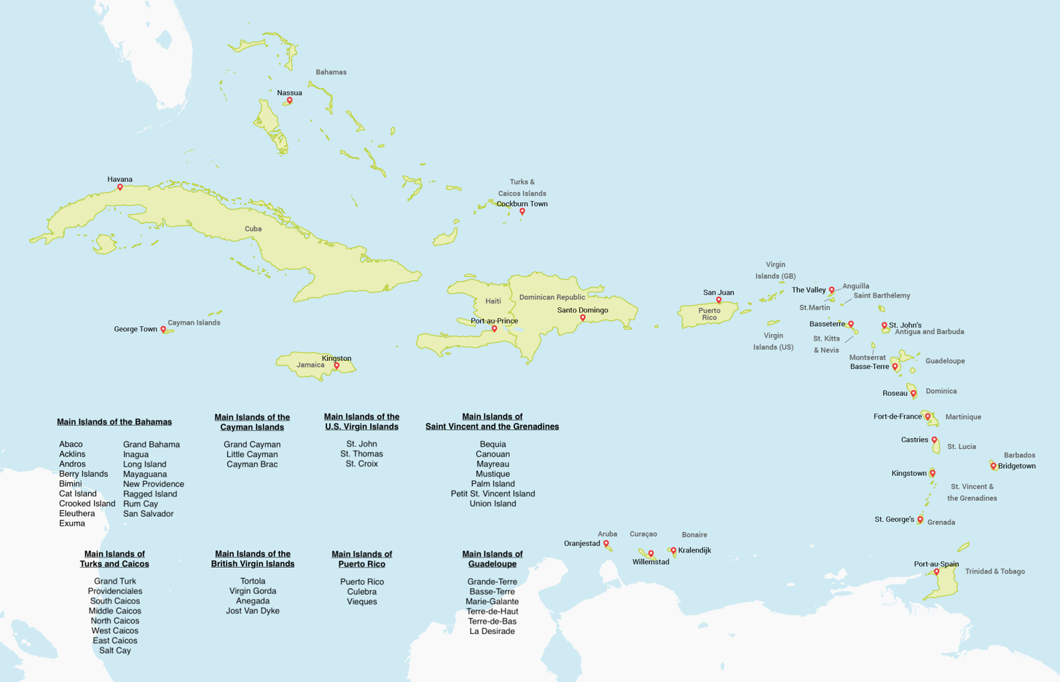

Figure 1: Map of the Caribbean region

[TBD: Add list of Caribbean countries]

[TBD: Add section overview]

[TBD: Add acknowledgement]

# Section II. Development Environment

## Project Resources

The following applications and software tools were used for the development and completion of this project:

* JupyterLab[2]: web-based interactive development environment for running Python
* Git: recommended local version control system for keeping track of updating files
* GitHub: web-based version control system used for publishing project
* Visual Studio Code: preferred IDE used for editing and managing the project files

This project was developed on a Unix system and coded primarily in Python 3 (the latest version of Python at the time of this document is recommended) with some programming scripts written in Bash. The following command-line tools were used in the completion of this senior thesis:

* Homebrew[3]: package manager for installing command-line and software utilities
* pip: Python package installers

Additionally, the software and programming libraries that were used for the analysis of this project are as follows:

* Matplotlib[4]: data visualization library for creating plots
* NumPy[5]: mathematical package for data computing
* pandas[6]: data analysis and manipulation library
* statsmodels[7]: statistical modelling and regression module
* linearmodels[8]: complementary library to statsmodels (i.e., fixed-effects regression)
* seaborn[9]: data visualization package based on Matplotlib

## Software Installation

*Note: This software installation section is written for a Unix-based system, such as MacOS or Linux, on which this project was developed on.*

First, installing Homebrew is recommended for the installation of all necessary software tools; run the following command to install:

|  |
| --- |
| **$ /bin/bash -c "$(curl -fsSL https://raw.githubusercontent.com/Homebrew/install/HEAD/install.sh)"** |

Using Homebrew, install all the necessary software components for this project including Python 3, JupyterLab, Git and the Python package manager:

|  |
| --- |
| **$ brew install python3**  **$ brew install jupyterlab**  **$ brew install git** |

Using Python’s pip package manager, install the latest versions of the remaining Python libraries by running the following set of commands:

|  |
| --- |
| **$ pip install matplotlib**  **$ pip install numpy**  **$ pip install pandas**  **$ pip install statsmodels**  **$ pip install linearmodels**  **$ pip install seaborn** |

More information on these software libraries and packages and their full set of functionalities are available on their respective online websites.

## Downloading the Project Files

All of the project files are hosted on an online GitHub repository available for public viewing and download at <https://github.com/andreiui/csec491>. In order to clone the repository, run the following command:

|  |
| --- |
| **$ git clone https://github.com/andreiui/csec491** |

This command will download all of the project files onto your local machine into a directory named “csec491” by default; alternatively, users can download the compressed ZIP file directly from the GitHub link.

After cloning the online repository or downloading the files onto your machine, open the project folder using the software editor of the user’s choice, although Virtual Studio Code is recommended; Figure 1 shows an example of the project files being loaded into the IDE.

The repository is structured into four main folders with task-specific subdirectories:



Figure 2: Example of project repository loaded in the Virtual Studio Code IDE

* “code”: contains all project code files for data analysis
  + “code/analysis”: has all of the data analysis code of the Caribbean region using Python and JupyterLab, subdivided into folders named for the corresponding Caribbean country
  + “code/common”: includes a Python file with commonly reused code and functions across analyses
* “data”: contains data-specific files, such as scripts for importing and exporting data and subfolders with raw and processed data files
  + “data/countries”: has all per-country data sorted into Excel files with tourism and COVID-19 numbers
  + “data/covid19”: includes all processed COVID-19 data for all Caribbean countries, divided into files storing daily, monthly and yearly rates
  + “data/raw”: contains all raw COVID-19 data for countries around the world extracted from external online repositories

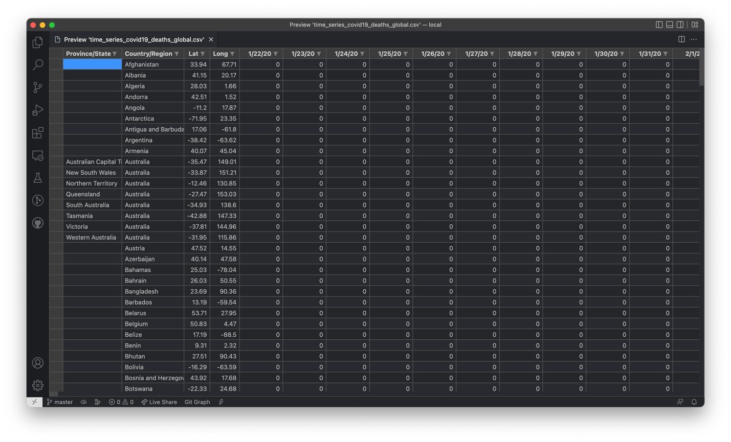

Figure 3: Raw time series of daily COVID-19 deaths data for global countries

* “docs”: has all documents relating to the development of this senior project, such as the initial senior thesis proposal and final project report
* “imgs”: includes all manually curated and generated images for this project

## Walkthrough of the Repository

In this part, we provide a comprehensive walkthrough of the repository and data-generation steps for ease of use by any user who wishes to expand on and use this project as a template. The steps outlined below serve as an informational and step-by-step guide for generating the Caribbean COVID-19 and tourism data for the scope of this project; however, these files have already been created and included in the project repository for ease and readiness of use.

Each code file has been well-commented to assist in readability and ease of understanding of the structure and functionality of the program. Additionally, subdirectories often include sources, either in Markdown, Excel or HTML format, outlining in great detail where each external piece of data was collected from that contributed to the fulfillment of this project.

### COVID-19 Data

In the “data/raw” directory, there are four CSV files containing raw unformatted information on the number of COVID-19 cases and deaths recorded in the U.S. and countries around the world and are descriptively titled as follows:

* “time_series_covid19_confirmed_global.csv”
* “time_series_covid19_confirmed_US.csv”
* “time_series_covid19_deaths_global.csv”
* “time_series_covid19_deaths_US.csv”

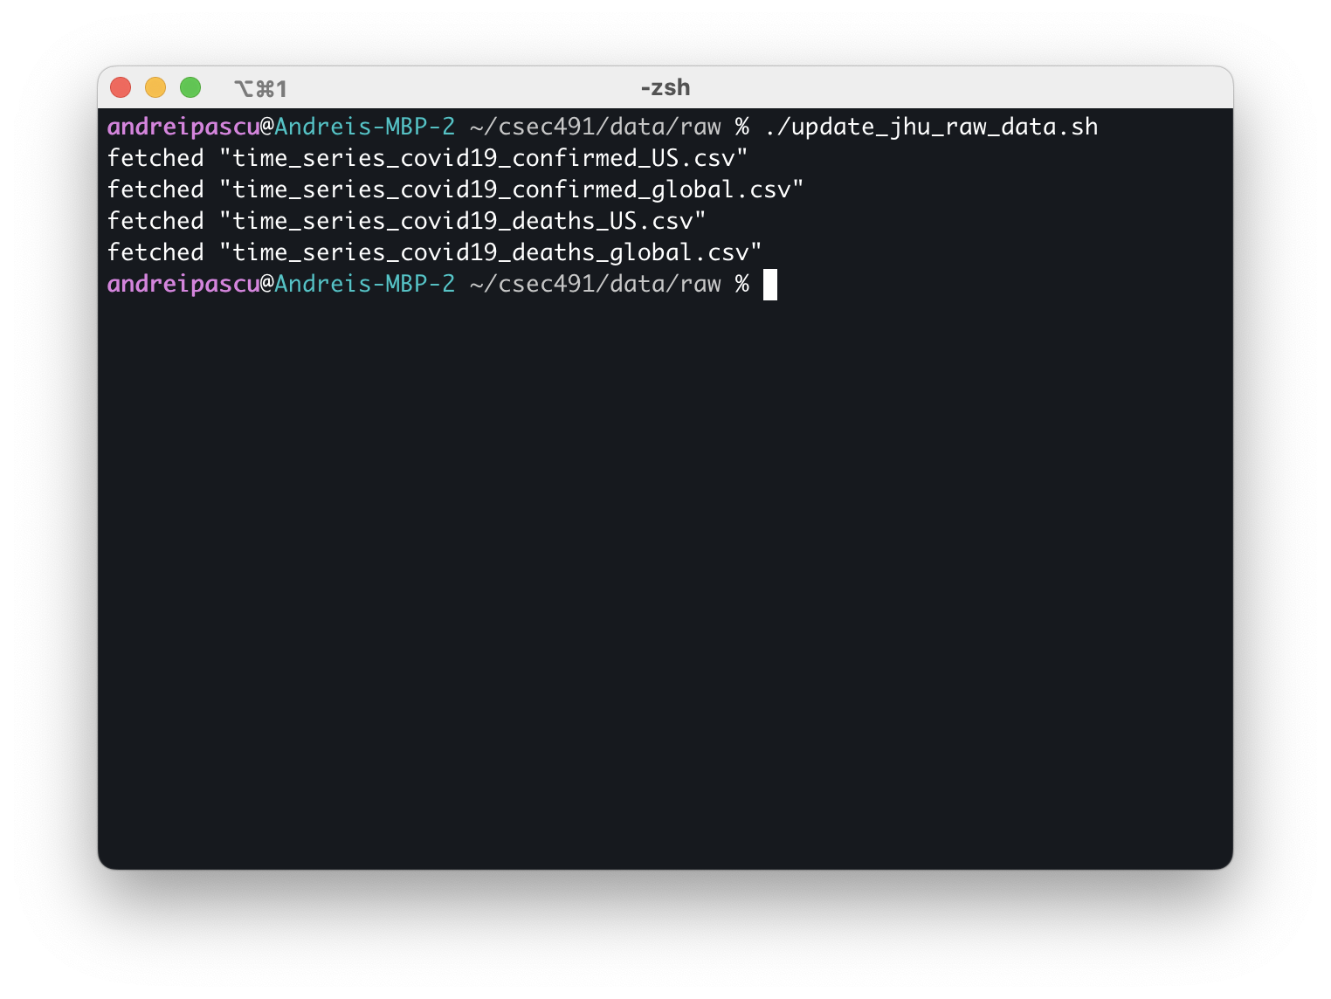

Figure 4: Sample run of the “update_jhu_raw_data.sh” Bash script

These files have been downloaded from the Johns Hopkins University online GitHub repository on COVID-19 data made available by the Center for Systems Science and Engineering (CSSE), which include cumulative daily COVID-19 rates starting on January 20, 2022. The repository is made public and available at <https://github.com/CSSEGISandData/COVID-19>. Figure 2 illustrates the structure of the raw file for the time series of COVID-19 global cases as an example.

The “update_jhu_raw_data.sh” file is a Bash script that automatically downloads and updates these time series files contained in the “csse_covid_19_data/csse_covid_19_time_series” subdirectory on JHU’s GitHub (last download snapshot occurred on March 1, 2023 at 12:30 PM EST). Figure 3 presents a sample run and output of this executable file.

In the parent “data” folder, the “export_caribbean_countries.py” Python file parses through the raw COVID-19 data and extracts the relevant information relevant for the Caribbean region; the list of countries selected is identical to that provided in Section I. The program reads from the “data/raw” subdirectory and parses all of the countries, porting each of the Caribbean countries to two new CSV files—for the incidence of cases and deaths. During its execution, the script outputs the start and end of processing each raw file and signals when it has finished generating the new files in the “data/covid19” folder; additionally, it will output any data discrepancies such as misaligned dates across the raw files and output the full count and set of countries that were processed. Figure 4 shows an example of running the Python script.

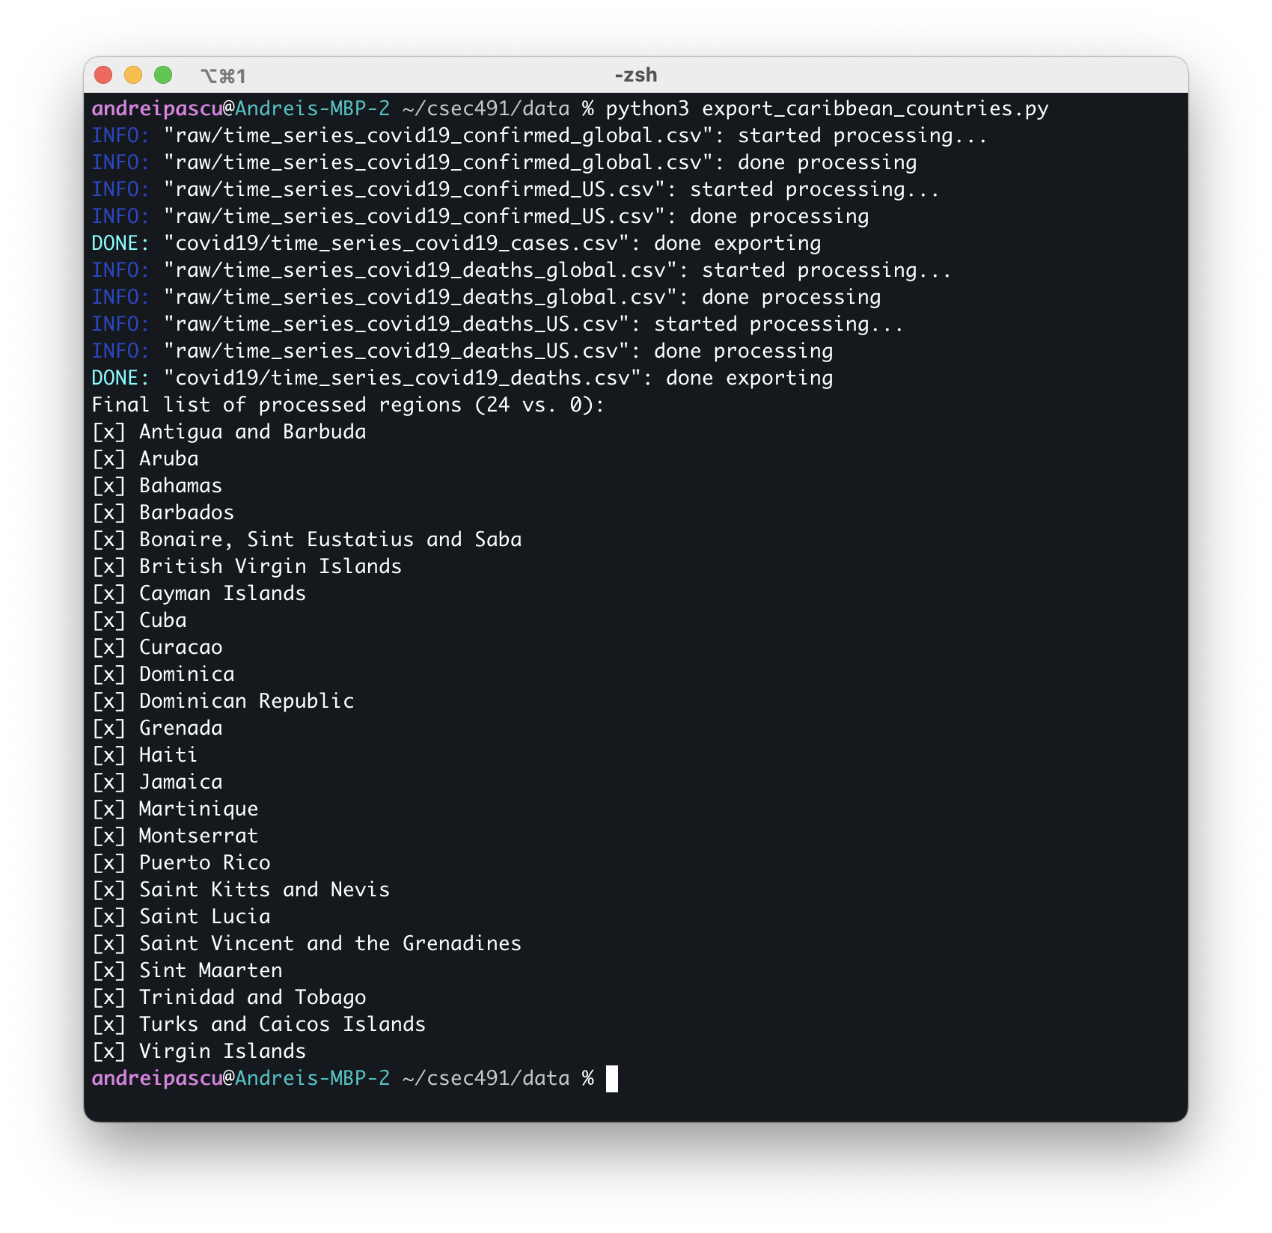

Figure 5: Sample run of the “export_caribbean_countries.py” Python file

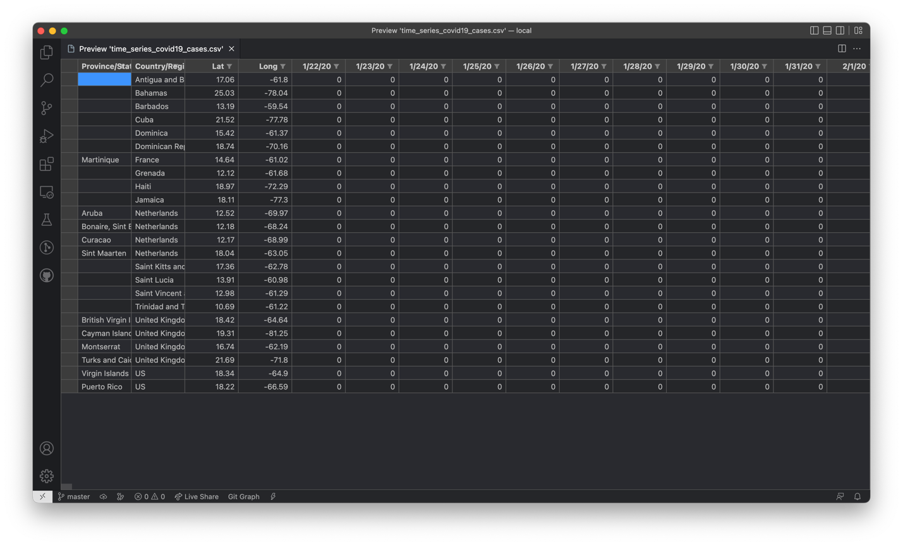

Figure 6: Generated COVID-19 cases for the Caribbean countries from the raw JHU data

The “data/covid19” subdirectory contains the generated files from the raw COVID-19 data after running the “export_caribbean_countries.py” Python script: “time_series_covid19_cases.csv” and “time_series_covid19_deaths.csv;” Figure 5 illustrates a preview of the file generated for COVID-19 cases pertinent to the Caribbeans. The numbers in these files correspond to daily cumulative rates; however, for the scope of this project, monthly and yearly rates are preferred for statistical analysis. The “generate_from_daily.py” Python file performs this conversion, transforming Caribbean cumulative daily data into monthly and yearly equivalents in four new CSV files:

* “cases_yearly.csv”
* “cases_monthly.csv”
* “deaths_yearly.csv”
* “deaths_monthly.csv”

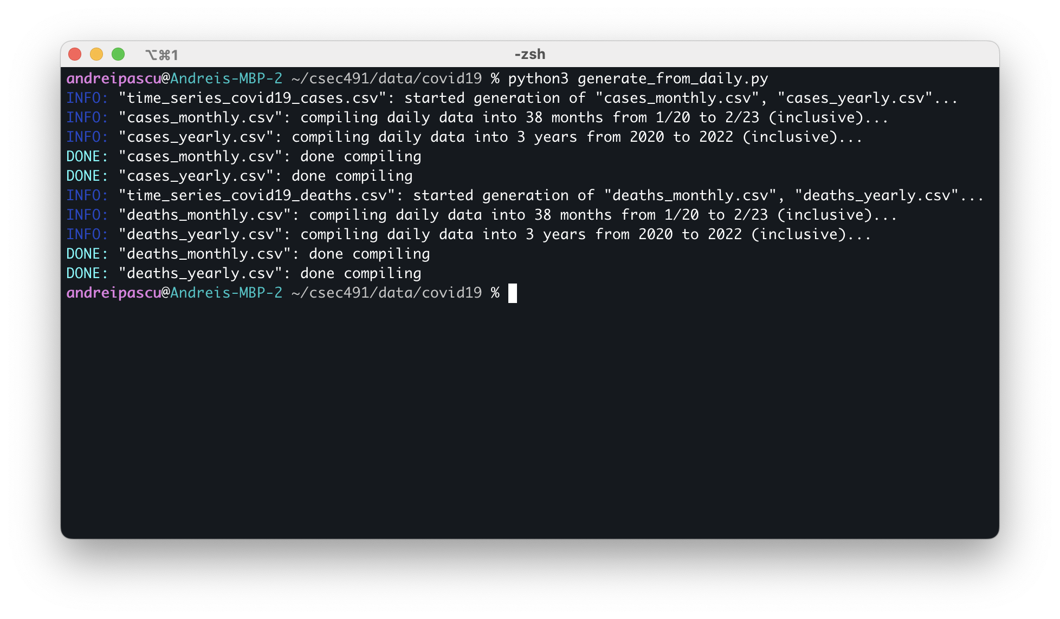

Figure 7: Sample run of the “generate_from_daily.py” Python file

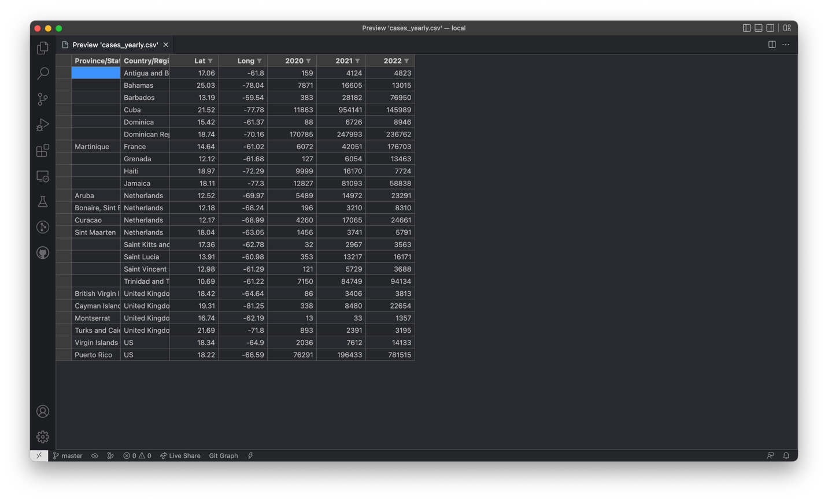

Figure 8: Generated COVID-19 yearly cases for Caribbean countries

Similar to the previous Python script, “generate_from_daily.py” outputs debug messages on the execution status of the program, informing the user of the start and completion of processing the data files. Figure 6 presents the output of the program, whereas Figure 7 illustrates the structure of one of the four generated files.

### Tourism Data

All of the Caribbean tourism data used for the scope of the statistical analysis for this project, such as number of tourists, expenditure and other economic variables of interest, have been compiled and manually curated from Statista[10]. The “data/sources” subdirectory contains a HTML table with online references to all of the various sources on the Caribbean tourism numbers; the data availability varies across each individual country with respect to economic variables and time periods. Some country-specific data may be missing for tourism volume, spending, overnight vs. same-day visitors, etc.; furthermore, data generally start from 2010 and frequently end in either 2020 and 2021 with some per-country exceptions.

The number of incoming tourists may be available in five categories: total volume of tourists, overnight or same-day visitors, and quantity of visitors arriving by cruise or air. Depending on the availability of this data, the total number of tourists may be derived. Additionally, the expenditure of incoming tourists is also segmented into total spending and monetary investment in travel or transportation to the region. Table 1 outlines the data availability on tourism for each Caribbean country in this project analysis.

The tourism data collected at the individual Caribbean country level presented in Table 1 is appended with its corresponding incidence of COVID-19 cases and deaths. In the subdirectory “data/countries,” all of the economic and pandemic data have been manually compiled on a per-country basis into Excel tables. Each of these contains an overview of the data with appropriate citations and online sources. Figure 8 and Figure 9 illustrate an example of a curated Excel file.

|  |  |  |  |  |  |  |  |  |  |  |
| --- | --- | --- | --- | --- | --- | --- | --- | --- | --- | --- |
| Country | Tourism Volume | | | | | | Tourism Expenditure | | | |
| Time-  frame | Total | Over-night | Same-day | Air | Cruise | Time-  frame | Total | Travel | Trans-port |
| Antigua & Barbuda | 2010–2021 | x |  |  |  |  | 2010–2021 | x |  |  |
| Aruba | 2010–2021 |  | x |  |  |  | 2010–2020 | x |  |  |
| Bahamas | 2010–2021 | x | x | x |  |  | 2010–2021 | x | x | x |
| Barbados | 2010–2020 | x | x | x |  |  | 2010–2020 |  | x |  |
| Bonaire, St. Eustatius & Saba | 2012–2021 |  |  |  | x |  | N/A |  |  |  |
| British Virgin Islands | 2010–2020 | x | x | x |  |  | 2010–2019 | x |  |  |
| Cayman Islands | 2010–2020 | x | x | x |  |  | 2010–2019 | x |  |  |
| Cuba | 2013–2021 | x |  |  |  |  | 2010–2021 | x | x | x |
| Curaçao | 2010–2020 | x | x* | x |  |  | 2010–2021 | x | x | x |
| Dominica | 2010–2021 | x |  |  |  |  | 2010–2021 | x |  |  |
| Dominican Republic | 2010–2021 | x |  |  | x | x | 2010–2021 | x |  |  |
| Grenada | 2010–2022 | x |  |  |  |  | N/A |  |  |  |
| Haiti | 2010–2020 | x | x | x |  |  | N/A |  |  |  |
| Jamaica | 2010–2020 |  | x |  |  |  | 2010–2020 | x |  |  |
| Martinique | 2010–2021 | x | x | x |  |  | N/A |  |  |  |
| Montserrat | 2010–2021 | x |  |  |  |  | 2010–2021 | x |  |  |
| Puerto Rico | 2014–2020 |  | x |  |  |  | 2010–2019 | x |  |  |
| St. Kitts & Nevis | 2010–2021 | x |  |  |  |  | 2010–2021 | x |  |  |
| St. Lucia | 2010–2021 | x |  |  |  |  | 2010–2021 | x |  |  |
| St. Vincent & Grenadines | 2010–2021 | x |  |  |  |  | 2010–2021 | x |  |  |
| St. Maarten | 2012–2021 |  |  |  |  | x | N/A |  |  |  |
| Trinidad & Tobago | 2010–2020 | x | x | x |  |  | 2010–2021 | x | x | x |
| Turks & Caicos | 2010–2021 | x |  |  |  |  | N/A |  |  |  |
| U.S. Virgin Islands | 2010–2020 | x |  |  |  |  | N/A |  |  |  |
|  | Pct. % | 79.2 | 45.8 | 33.3 | 8.3 | 8.3 | Pct. % | 66.7 | 20.8 | 16.7 |

(* 2010–2021)

Table 1: Per-country data availability (last row indicates percentage of countries with per-column availability); data collected from Statista ([statista.com](https://www.statista.com/))

Furthermore, all of the COVID-19 and tourism data collected in the Excel files created for each Caribbean country is accumulated into the “_CARIBBEAN.xlsx” file as a panel data for econometric analysis of the entire available Caribbean region, in order to identify averaging trends among the list of selected countries and utilize a larger dimension of data for more precise and informative regressions.

### Analysis Code

As previously described in the outline of the structure of the project files, the “code” folder contains all pertinent programs used to analyze the Caribbean data using Python, statistical regressions libraries in JupyterLab and display intuitive plots using Matplotlib. In order to access the generated data, the Bash script “sync_data.sh” in the base directory of the project copies all information in the Excel files in the “data/countries” folder and synchronizes it into folder names matching the origin filenames, creating “Data.csv” files containing all of the data for that specific country—for example, the file “data/countries/bahamas.xlsx” is copied over into the “code/analysis/bahamas/Data.csv” file. The same principle applies for the “_CARIBBEAN.xlsx” file containing the Caribbean panel data.



Figure 9: Sample Excel overview page (e.g., Bahamas)

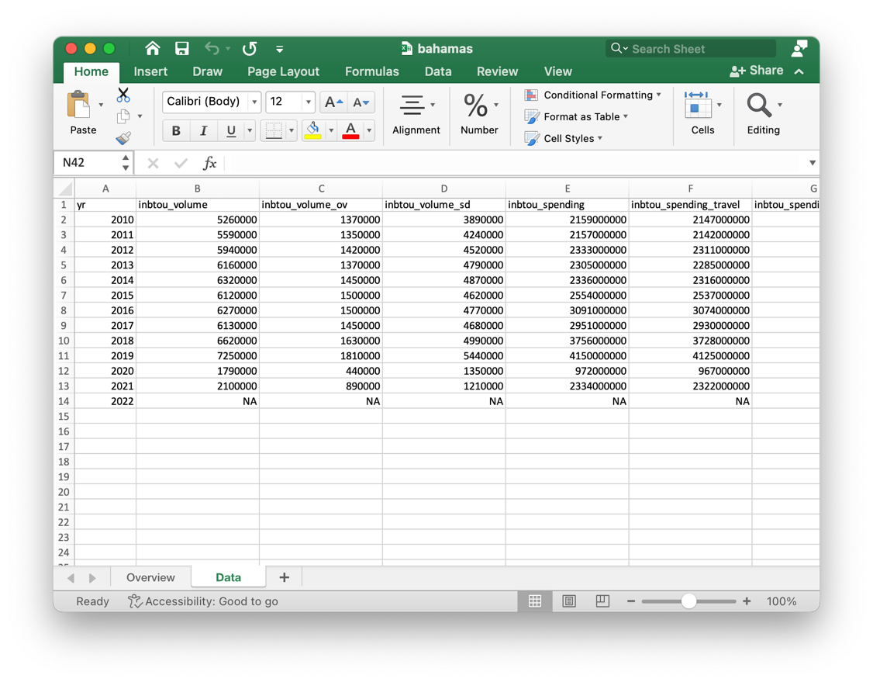

Figure 10: Sample Excel data sheet (e.g., Bahamas)

Figure 10 shows the output of executing the “sync_data.sh” script to synchronize the Caribbean economic and COVID-19 data from the “data” folder to the “code” directory. In the case of an error about “gnumeric” or “ssconvert,” run the following command:

|  |
| --- |
| **$ brew install gnumeric** |

Then retry running “sync_data.sh.”

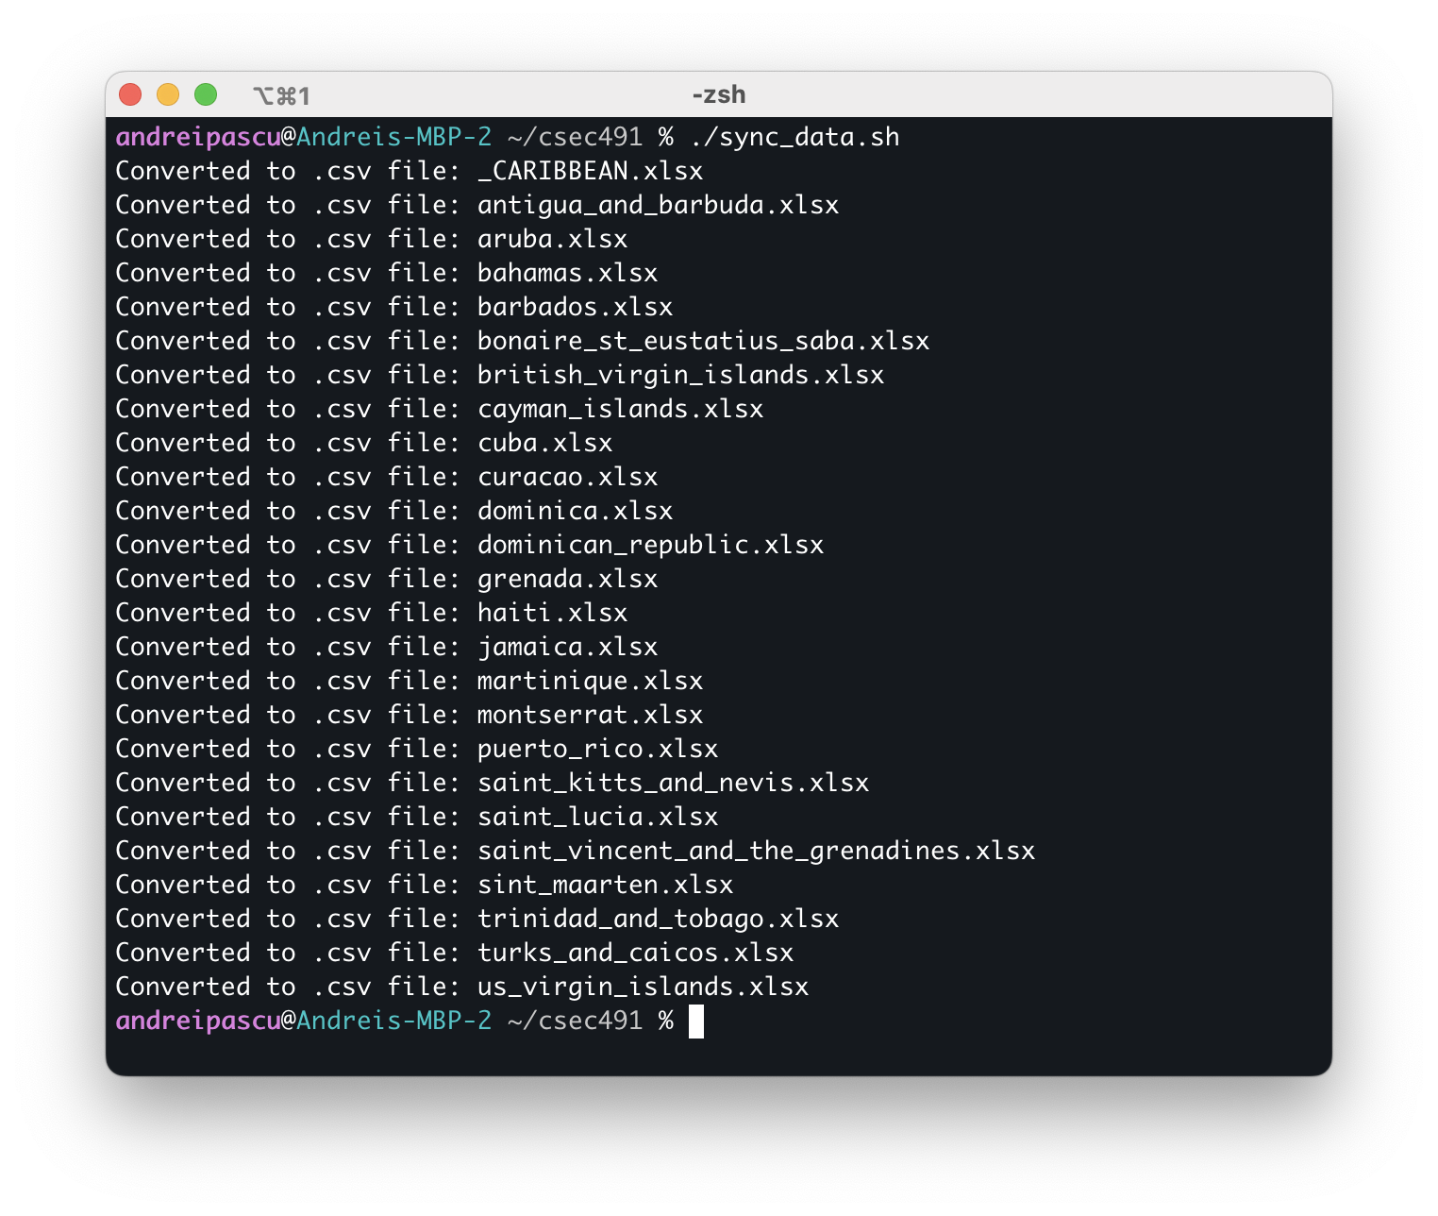

Figure 11: Sample run of the “sync_data.sh” Bash script

After the synchronization step outline above is completed, data are ready to be analyzed. Jupyter notebook files titled “main.ipynb” are contained within each Caribbean panel and per-country folder. Many of these files import from the “code/common” folder, which includes a “common.py” Python module that contains function definitions for frequently used code, such as generating difference-in-differences plots and performing OLS regression. The definitions of the variables included in the datasets are as follows:

* “inbtou_volume:” Total inbound number of tourists
* “inbtou_volume_ov:” Number of visitors staying overnight
* “inbtou_volume_sd:” Number of tourists visiting no longer than one day
* “inbtou_spending:” Total tourist expenditure
* “inbtou_spending_travel:” Amount spent during travel at the destination
* “inbtou_spending_transport:” Amount spent on passenger transport to the destination
* “covid19_cases:” Number of COVID-19 cases
* “covid19_deaths:” Number of COVID-19 deaths
* “covid19_mortality:” COVID-19 mortality rate

In order to access these files, it is recommended to use JupyterLab for viewing, editing and execution of the notebook files. In a terminal window, change directories to the “code/analysis” folder and run the following command:

|  |
| --- |
| **$ jupyter-lab** |

After a few seconds of executing the command, an internet browser window should appear with the JupyterLab interface. To investigate a country’s analysis or the panel regression, open the corresponding folder and the “main.ipynb” Python notebooks. Sections III and IV present the results that were obtained from running the econometric analyses contained within these files.

# Section III. Individual Caribbean Country Analysis

This section focuses on the per-country analysis and is dependent on the data availability for the respective region. Most countries have trending economic data starting in 2010 through 2019 and continues through the onset of the pandemic. The first analysis technique considers the pre-2020 data as a representative trendline that projects the hypothetical economic values in the absence of COVID-19. We use the slope of the line of best-fit to estimate the impact of the pandemic during 2020 and following years by computing the intercept difference between the predicted—i.e., under the hypothesis that a health crisis never occurred in the year 2020—and recorded post-pandemic data.

This method of analysis resembles a pseudo-difference-in-differences technique used in statistical models with the notable exception that there is no control group; the pandemic affected all countries around the world and we can only theorize about the economy had COVID-19 not been present. To this extent, we assume a pseudo-control group constructed through a projection based on the time series trend observed in the years prior to 2020, in order to give a quantitative evaluation into the impact of the pandemic on the Caribbean tourism sector. We estimate the per-country average economic effect during the pandemic timeframe using the following statistical model:

|  |  |  |
| --- | --- | --- |
|  | $$Y_{t}=β_{0}+β_{1}t+β_{2}1_{t}(t≥2020)$$ | (1) |

The dependent variable $Y_{t}$ in Equation 1 corresponds to the economic data of choice—e.g., the volume and expenditure of incoming tourists—whereas $β_{1}$ represents the yearly trend from the pre-2020 data available and $β_{2}$ constitutes the average effect of the COVID-19 pandemic during 2020 and further years: $1_{t}(t≥2020)$ is an indicator variable for years succeeding the onset of the pandemic.

Using these estimates, we construct informative pseudo-difference-in-differences per-country plots presenting the predicted loss in inbound tourism volume and expenditure from COVID-19.

|  |  |  |  |  |  |  |
| --- | --- | --- | --- | --- | --- | --- |
| Country | COVID-19 cases | | COVID-19 deaths | | COVID-19 mortality | |
| 2020 | 2021 | 2020 | 2021 | 2020 | 2021 |
| Antigua & Barbuda | 159 | 4,124  (2,493%) | 5 | 114  (2,180%) | 3.14% | 2.76%  (-12%) |
| Aruba | 5,489 | 14,972  (173%) | 49 | 132  (169%) | 0.89% | 0.88%  (-1%) |
| Bahamas | 7,871 | 16,605  (111%) | 170 | 547  (222%) | 2.16% | 3.29%  (53%) |
| Barbados | 383 | 28,182  (7,258%) | 7 | 253  (3,514%) | 1.83% | 0.90%  (-51%) |
| Bonaire, St. Eustatius & Saba | 196 | 3,210  (1,538%) | 3 | 20  (567%) | 1.53% | 0.62%  (-59%) |
| British Virgin Islands | 86 | 3,406  (3,860%) | 1 | 38  (3,700%) | 1.16% | 1.12%  (-4%) |
| Cayman Islands | 338 | 8,480  (2,409%) | 2 | 9  (350%) | 0.59% | 0.11%  (-82%) |
| Cuba | 11,863 | 954,141  (7,943%) | 146 | 8,176  (5,500%) | 1.23% | 0.86%  (-30%) |
| Curaçao | 4,260 | 17,065  (301%) | 14 | 175  (1150%) | 0.33% | 1.03%  (212%) |
| Dominica | 88 | 6,726  (7,543%) | 0 | 47  (–) | 0% | 0.70%  (–) |
| Dominican Republic | 170,785 | 247,993  (45%) | 2,414 | 1,833  (-24%) | 1.41% | 0.74%  (-48%) |
| Grenada | 127 | 6,054  (4,667%) | 0 | 200  (–) | 0% | 3.30%  (–) |
| Haiti | 9,999 | 16,170  (62%) | 236 | 537  (128%) | 2.36% | 3.32%  (41%) |
| Jamaica | 12,827 | 81,093  (532%) | 302 | 2,171  (619%) | 2.35% | 2.68%  (14%) |
| Martinique | 6,072 | 42,051  (593%) | 42 | 735  (1650%) | 0.69% | 1.75%  (153%) |
| Montserrat | 13 | 33  (154%) | 1 | 0  (-100%) | 7.69% | 0.00%  (-100%) |
| Puerto Rico | 76,291 | 196,433  (157%) | 1,503 | 1,802  (20%) | 1.97% | 0.92%  (-53%) |
| St. Kitts & Nevis | 32 | 2,967  (9,172%) | 0 | 28  (–) | 0% | 0.94%  (–) |
| St. Lucia | 353 | 13,217  (3,644%) | 5 | 290  (5,700%) | 1.42% | 2.19%  (55%) |
| St. Vincent & Grenadines | 121 | 5,729  (4,635%) | 0 | 81  (–) | 0% | 1.41%  (–) |
| St. Maarten | 1,456 | 3,741  (157%) | 27 | 48  (78%) | 1.85% | 1.28%  (-31%) |
| Trinidad & Tobago | 7,150 | 84,749  (1,085%) | 127 | 2,742  (2,059%) | 1.78% | 3.24%  (82%) |
| Turks & Caicos | 893 | 2,391  (168%) | 6 | 20  (233%) | 0.67% | 0.84%  (24%) |
| U.S. Virgin Islands | 2,036 | 7,612  (274%) | 23 | 66  (187%) | 1.13% | 0.87%  (-23%) |

Table 2: COVID-19 cases, deaths and mortality rates for selected Caribbean countries (parenthesis indicate the percent increase in 2021 from 2020); data collected from COVID-19 Data Repository by the Center for Systems Science and Engineering (CSSE) at Johns Hopkins University ([github.com/CSSEGISandData/COVID-19](https://github.com/CSSEGISandData/COVID-19))

Second, we perform a linear OLS regression on the selected econometric variables on the number of COVID-19 cases, deaths and mortality rate. The model that is used is as follows:

|  |  |  |
| --- | --- | --- |
|  | $$\log{Y_{t}}=β_{0}+β_{1}t+ β_{2}x_{t}+\sum_{i=2021}^{T}{β_{(i-2018)}x_{t}1_{t}(t=i)}$$ | (2) |

Equation 2 represents a log-level statistical analysis and therefore alters the interpretation of each of the estimated coefficients. Distinct from the prior regression, $\log{Y_{t}}$ corresponds to the economic variable which has been transformed into logarithmic value, whereas $x_{t}$ is the main regressor in the model—here chosen to represent the number of COVID-19 cases, deaths or mortality rates across different regression runs. $β_{1}$ captures the annual economic trend.

Importantly, $β_{2}$ denotes the percent increase in the original dependent variable which results from a marginal increase in the regressor $x_{t}$; in other words, a one-unit increase in $x_{t}$ results in a ${100⋅β}_{2}$ percent increase in $Y_{t}$. In the case of COVID-19 cases and deaths, we can interpret the coefficients directly. However, mortality rates are represented in the dataset in percentage values, rendering a one-unit increase in the regressor as a 100 percent mortality growth. The proportional death rate of the COVID-19 virus is in the 1 to 10 percent range; thus, when interpreting the coefficient estimate for mortality rates as the regressor, we divide the numerical value by 100 to instead be interpreted as follows: a 1 percentage point increase in the mortality rate results in a $β_{2}$ percent increase in $Y_{t}$. The remaining term in Equation 2 consists of indicator variables after and on the year 2021 that contextualize the significance of the $β_{2}$ estimate: it is the impact on the economic variable from a marginal increase in the regressor $x_{t}$ conditional on the year 2020. Consequently, it acts as the effect specific for the onset year of the COVID-19 pandemic and as the baseline point-of-reference for the remaining coefficient estimates.

The variable $T$ represents the end year for the available data. Note that if $T$ is equal to 2020, the summation term is nullified and is thus not included in the regression. For $T$ larger than 2020, each $x_{t}1_{t}(t=i)$ represents the intersection between the COVID-19 regressor variable and the indicator variable $1_{t}\left(t=i\right)$ for year $i$, for $i$ starting at year 2021 and ending in year $T$. The purpose of these intersected variables is to observe baseline changes to the impact of the regressor $x_{t}$ in the year 2020: $β_{3}$, $β_{4}$ and so forth are the effects of a marginal increase in the regressor on the dependent variable relative to the baseline $β_{2}$ estimate, conditional on the year 2021, 2022 and so forth, respectively. More precisely, if the regressor is the number of COVID-19 cases and $T$ is equal to 2022, then $β_{2}$ is the baseline impact of case incidence on the economic dependent variable in the year 2020, whereas $β_{3}$ is the effect of COVID-19 cases in the year 2021 relative to that of 2020: therefore, the actual effect of cases on the dependent variable for the year 2021 is $(β_{2}+β_{3})$, whereas for 2022 it is [11].

In the scope of this analysis, most data ends in the year 2020, 2021 or 2022, and thus the linear regression takes on one of the three following concise forms:

|  |  |  |
| --- | --- | --- |
|  | $$\log{Y_{t}}=β_{0}+β_{1}t+β_{2}x_{t}$$ | (2.1) |
|  | $$\log{Y_{t}}=β_{0}+β_{1}t+β_{2}x_{t}+β_{3}x_{t}1_{t}(t=2021)$$ | (2.2) |
|  | $$\log{Y_{t}}=β_{0}+β_{1}t+β_{2}x_{t}+β_{3}x_{t}1_{t}(t=2021)+β_{4}x_{t}1_{t}(t=2022)$$ | (2.3) |

Equation 2.1 corresponds to datasets that end in the year 2020; thus, the $β_{2}$ coefficient represents impact of COVID-19 observed during the onset of the pandemic. Equation 2.2 is for data terminating in the year 2021; the $β_{2}$ coefficient is the baseline effect for the year 2020 and $β_{3}$ is the impact in 2021 relative to that observed in 2020[12],[13]. Lastly, Equation 2.3 is used for data ending in 2022: $β_{2}$ is the baseline impact in 2020, whereas $β_{3}$ and $β_{4}$ are the relative effects for 2021 and 2022 with respect to 2020[14].

The rest of this section presents the results using the data presented in Table 1 and the analyses outlined in Equations 1, 2.1, 2.2 and 2.3. Figure 12 through [TBD] illustrate visual plots for each country with data available on selected economic variable: total, overnight and same-day inbound tourism volume and total, travel and transport spending by incoming tourists. Table 3 through [TBD] present in a tabular format the coefficient estimates obtained from the analysis methods previously described in this section using Equation 2. All of the relevant code for each equation is included in the “code/common/common.py” Python file and in each of the “main.ipynb” for all Caribbean countries.

The following subsections highlight the resulting data; however, it is important to note the caveat of limited data points which result in a small sample size problem; thus, the coefficient estimates should be treated with the scope of the data availability in mind.

## Antigua and Barbuda

Table 3 and Figure 12 show the results from the linear regression analyses for Antigua and Barbuda.

We estimate an average loss of 766,000 (plus-minus 10 percent) inbound tourists and 283 million USD (± 59 million USD) into the economy due to the pandemic—see Table 3, Equation 1. The visual data in Figure 12 gives evidence of upward trends for both economic variables; however, the number of tourists went down in 2021 from 2020 whereas their expenditure increased. Both plots illustrate a significant predicted loss of both popularity and revenue into the country.

Table 3, Equation 2 coefficient estimates suggest an overall economic recovery from in the year 2021 relative to the start of the pandemic:

|  |  |  |  |  |  |  |  |
| --- | --- | --- | --- | --- | --- | --- | --- |
| Antigua and Barbuda | | | | | | | |
| $$Y_{t}$$ | (1) | (2) | | | | | |
| Estimated COVID-19 Impact | $x_{t}=$ COVID-19 cases | | $x_{t}=$ COVID-19 deaths | | $x_{t}=$ COVID-19 mortality | |
| 2020 | 2021 | 2020 | 2021 | 2020 | 2021 |
| Tourism Volume  (Total) | -766,231  (±75,612) | -.0063* | .006* | -.2009* | .1878* | -31.94* | -22.07* |
| Tourism Spending  (Total) | -2.83×108 (±0.59×108) | -.0043* | .0042* | -.1357* | .1325* | -21.57* | 8.49+ |

Table 3: OLS results for Antigua and Barbuda; estimated COVID-19 impact from Equation 1 includes 95% confidence interval in parenthesis; estimates for Equation 2 include p-values (*: p<.05; +: .05<p<.1)

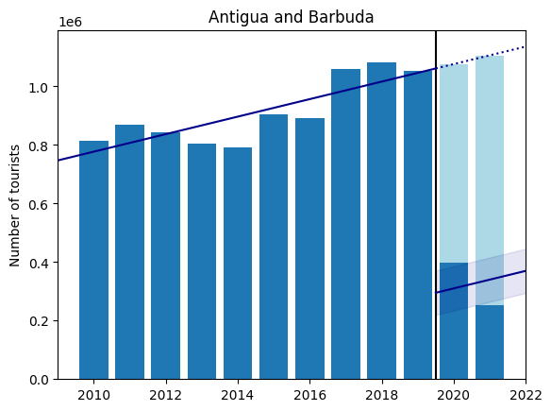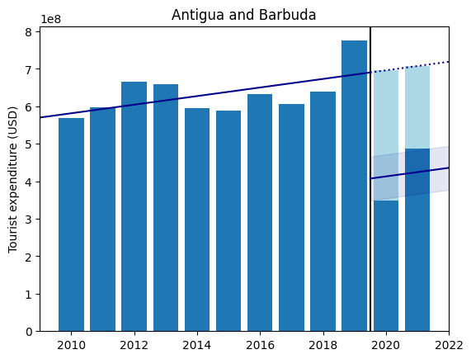

Figure 12: Economic impact of COVID-19 in Antigua and Barbuda on inbound tourism volume (total) and spending (total); dark blue bars are observed data, light blue represents predicted loss from COVID-19; trendline for pre-pandemic years with estimated pandemic effect 95% including confidence band

* A marginal increase in COVID-19 cases is associated to a 0.63% decrease in the number of incoming tourists and a 0.43% reduction in annual tourism expenditure. However, Antigua and Barbuda experiences a 0.6% increase in tourism volume and a 0.42% upturn in spending by inbound tourists per case of COVID-19 relative to that recorded in 2020.
* The same can be concluded with COVID-19 deaths with a significant drop: -20.09% change in the number of tourists and -13.57% change in tourist spending for the year 2020 versus -1.31% and -0.32% absolute changes per additional death observed in 2021 (18.78% and 13.25% increase from 2020 baseline).
* Changes in the number of tourists arriving in Antigua and Barbuda economy became more sensitive to changes in the COVID-19 mortality rate: a one percentage point increase is associated with 31.94% and 54.01% less incoming visitors in 2020 and 2021, respectively. In conjunction with less elasticity in cases and deaths, this suggests a return to pre-pandemic since higher relative mortality is more destabilizing to the economy

For each successive country, the interpretations are analogous unless otherwise specified (i.e., see footnotes 11 through 14). Henceforth, the most interesting results are highlighted.

## Aruba

|  |  |  |  |  |  |  |  |
| --- | --- | --- | --- | --- | --- | --- | --- |
| Aruba | | | | | | | |
| $$Y_{t}$$ | (1) | (2) | | | | | |
| Estimated COVID-19 Impact | $x_{t}=$ COVID-19 cases | | $x_{t}=$ COVID-19 deaths | | $x_{t}=$ COVID-19 mortality | |
| 2020 | 2021 | 2020 | 2021 | 2020 | 2021 |
| Tourism Volume  (Overnight) | -652,194 (±123,942) | -.0002* | .0002* | -.0246* | .0211* | -134.87* | -83.35* |
| Tourism Spending  (Total) | -1.07×109 (±0.58×109) | -.0001* | N/A | -.0147* | N/A | -80.88* | N/A |

Table 4: OLS results for Aruba; estimated COVID-19 impact from Equation 1 includes 95% confidence interval in parenthesis; estimates for Equation 2 include p-values (*: p<.05; +: .05<p<.1)

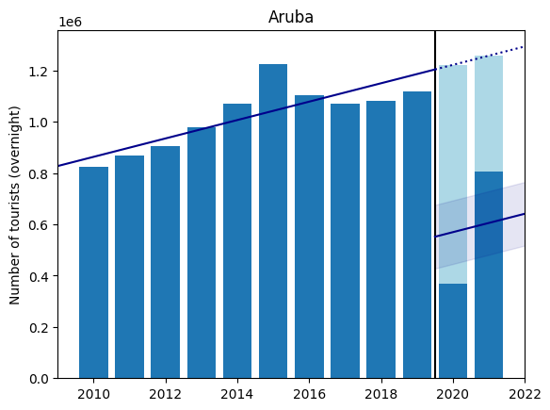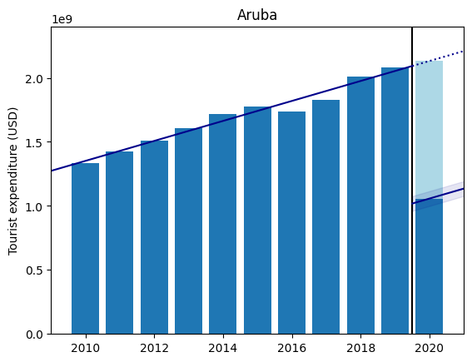

Figure 13: Economic impact of COVID-19 in Aruba on inbound tourism volume (overnight) and spending (total); dark blue bars are observed data, light blue represents predicted loss from COVID-19; trendline for pre-pandemic years with estimated pandemic effect including 95% confidence band

Table 4 and Figure 13 show the plots and econometric results for Aruba. In the number of overnight visitors, we observe a steady return to relative normalcy in 2021 with a dramatic increase from 2020 levels. Less impactful COVID-19 cases and deaths and higher sensitivity for mortality implies a steady economic recovery in the years following the onset of the pandemic.

## Bahamas

Table 5 and Figure 14 show the results for the Bahamas.

|  |  |  |  |  |  |  |  |
| --- | --- | --- | --- | --- | --- | --- | --- |
| Bahamas | | | | | | | |
| $$Y_{t}$$ | (1) | (2) | | | | | |
| Estimated COVID-19 Impact | $x_{t}=$ COVID-19 cases | | $x_{t}=$ COVID-19 deaths | | $x_{t}=$ COVID-19 mortality | |
| 2020 | 2021 | 2020 | 2021 | 2020 | 2021 |
| Tourism Volume  (Total) | -5,179,192 (±252,272) | -.0002* | .0001* | -.0081* | .0058* | -63.67* | 25.99* |
| Tourism Volume  (Overnight) | -1,071,566 (±123,964) | -.0002* | .0001* | -.008* | .0067* | -62.68* | 42.19* |
| Tourism Volume  (Same-day) | -4,107,626 (±223,648) | -.0002* | .0001* | -.0081* | .0054* | -63.99* | 17.92* |
| Tourism Spending  (Total) | -2.43×109 (±0.4×109) | -.0002* | .0001* | -.0084* | .0072* | -65.83* | 47.07* |
| Tourism Spending  (Travel) | -2.41×109 (±0.4×109) | -.0002* | .0001* | -.0084* | .0072* | -65.76* | 47.04* |
| Tourism Spending  (Transport) | -1.84×107 (±0.35×107) | -.0002* | .0002* | -.0099* | .0083* | -77.82* | 51.52* |

Table 5: OLS results for the Bahamas; estimated COVID-19 impact from Equation 1 includes 95% confidence interval in parenthesis; estimates for Equation 2 include p-values (*: p<.05; +: .05<p<.1)

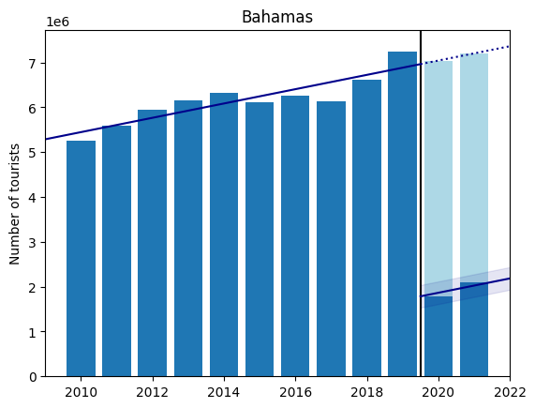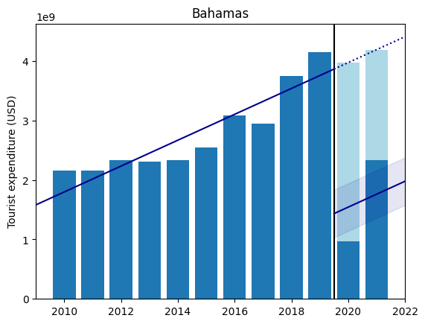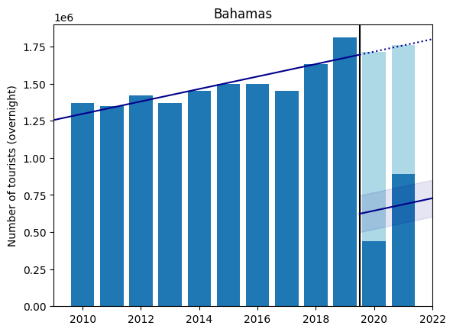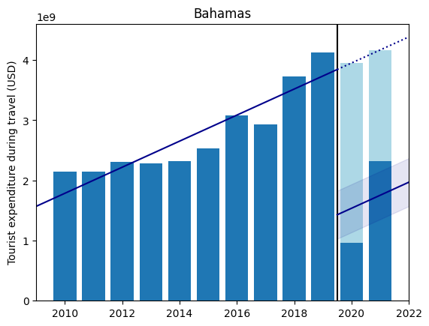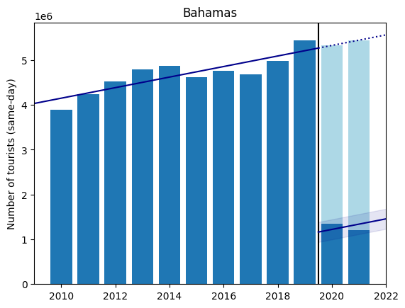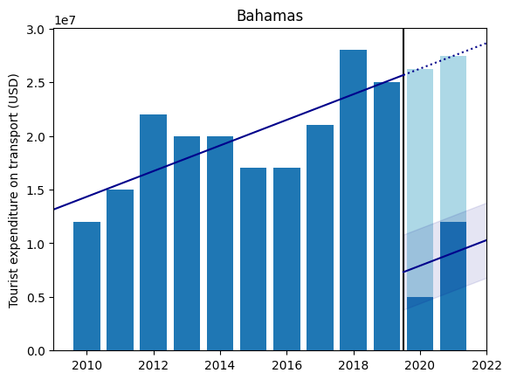

Figure 14: Economic impact of COVID-19 in the Bahamas on inbound tourism volume (total, overnight and same-day) and spending (total, travel and transport); dark blue bars are observed data, light blue represents predicted loss from COVID-19; trendline for pre-pandemic years with estimated pandemic effect including 95% confidence band

## Barbados

Table 6 and Figure 15 show the results for Barbados; note that there is only data up to 2020.

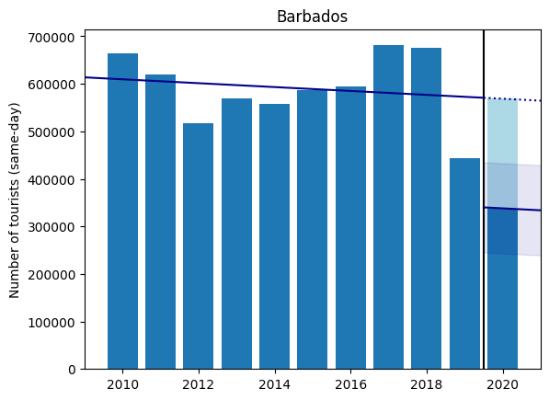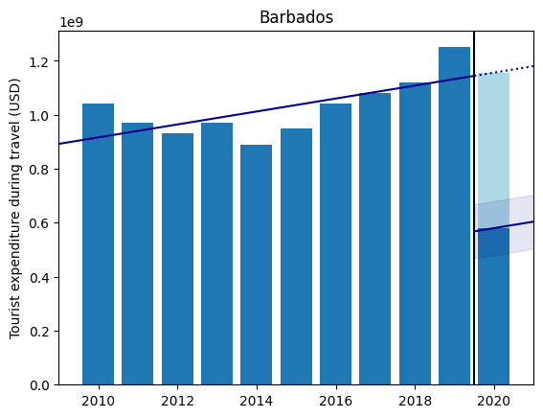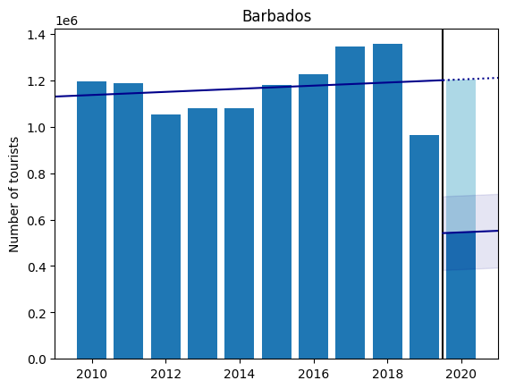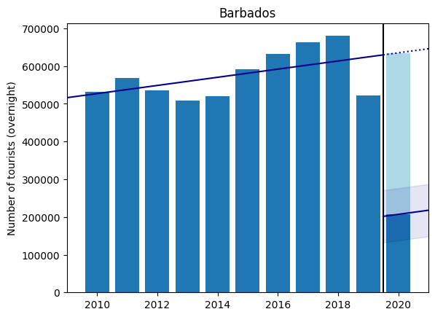

Figure 15: Economic impact of COVID-19 in Barbados on inbound tourism volume (total, overnight and same-day) and spending (travel); dark blue bars are observed data, light blue represents predicted loss from COVID-19; trendline for pre-pandemic years with estimated pandemic effect including 95% confidence band

|  |  |  |  |  |
| --- | --- | --- | --- | --- |
| Barbados | | | | |
| $$Y_{t}$$ | (1) | (2) | | |
| Estimated COVID-19 Impact | $x_{t}=$ COVID-19 cases | $x_{t}=$ COVID-19 deaths | $x_{t}=$ COVID-19 mortality |
| 2020 | 2020 | 2020 |
| Tourism Volume  (Total) | -658,733 (±158,836) | -.002* | -.1113* | -42.64* |
| Tourism Volume  (Overnight) | -428,133 (±69,359) | -.0029* | -.1594* | -61.07* |
| Tourism Volume  (Same-day) | -230,600 (±94,921) | -.0013* | -.0717* | -27.46* |
| Tourism Spending  (Travel) | -5.76×108 (±108) | -.0018* | -.0981* | -37.57* |

Table 6: OLS results for Barbados; estimated COVID-19 impact from Equation 1 includes 95% confidence interval in parenthesis; estimates for Equation 2 include p-values (*: p<.05; +: .05<p<.1)

## Bonaire, St. Eustatius and Saba

Table 7 and Figure 16 show the results for Bonaire, St. Eustatius and Saba.

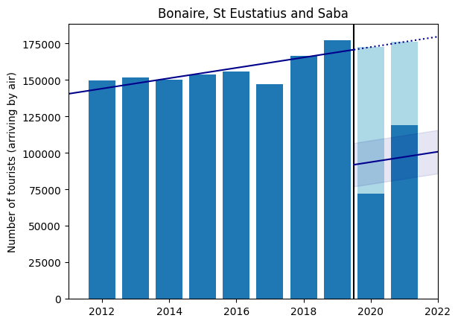

Figure 16: Economic impact of COVID-19 in Bonaire, St. Eustatius and Saba on inbound tourism volume (air); dark blue bars are observed data, light blue represents predicted loss from COVID-19; trendline for pre-pandemic years with estimated pandemic effect including 95% confidence band

|  |  |  |  |  |  |  |  |
| --- | --- | --- | --- | --- | --- | --- | --- |
| Bonaire, St. Eustatius and Saba | | | | | | | |
| $$Y_{t}$$ | (1) | (2) | | | | | |
| Estimated COVID-19 Impact | $x_{t}=$ COVID-19 cases | | $x_{t}=$ COVID-19 deaths | | $x_{t}=$ COVID-19 mortality | |
| 2020 | 2021 | 2020 | 2021 | 2020 | 2021 |
| Tourism Volume  (Air) | -78,838 (±14,898) | -.0044* | .0043* | -.2859* | .2671* | -56.05* | -4.36 |

Table 7: OLS results for Bonaire, St. Eustatius and Saba; estimated COVID-19 impact from Equation 1 includes 95% confidence interval in parenthesis; estimates for Equation 2 include p-values (*: p<.05; +: .05<p<.1)

## British Virgin Islands

Table 8 and Figure 17 show the results for the British Virgin Islands.

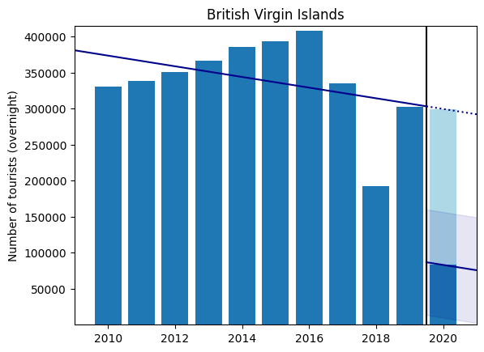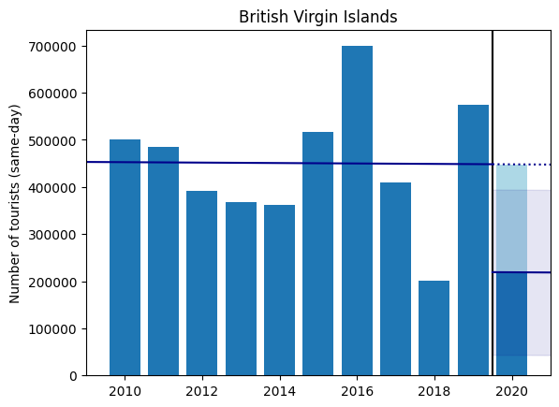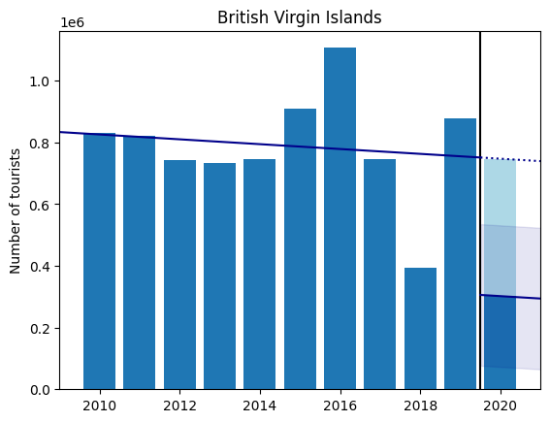

Figure 17: Economic impact of COVID-19 in the British Virgin Islands on inbound tourism volume (total, overnight and same-day); dark blue bars are observed data, light blue represents predicted loss from COVID-19; trendline for pre-pandemic years with estimated pandemic effect including 95% confidence band

|  |  |  |  |  |
| --- | --- | --- | --- | --- |
| British Virgin Islands | | | | |
| $$Y_{t}$$ | (1) | (2) | | |
| Estimated COVID-19 Impact | $x_{t}=$ COVID-19 cases | $x_{t}=$ COVID-19 deaths | $x_{t}=$ COVID-19 mortality |
| 2020 | 2020 | 2020 |
| Tourism Volume  (Total) | -445,466 (±229,352) | -.0096* | -.8261* | -71.04* |
| Tourism Volume  (Overnight) | -216,399 (±73,298) | -.0144* | -1.237* | -106.39* |
| Tourism Volume  (Same-day) | -229,066 (±175,331) | -.0069 | -.5943 | -51.11 |

Table 8: OLS results for the British Virgin Islands; estimated COVID-19 impact from Equation 1 includes 95% confidence interval in parenthesis; estimates for Equation 2 include p-values (*: p<.05; +: .05<p<.1)

We observe from the plots that total and overnight visitors have been significantly declining prior to the year 2020, widening the confidence interval of the COVID-19 impact on tourism.

## Cayman Islands

Table 9 and Figure 18 show the results for the Cayman Islands.

|  |  |  |  |  |
| --- | --- | --- | --- | --- |
| Cayman Islands | | | | |
| $$Y_{t}$$ | (1) | (2) | | |
| Estimated COVID-19 Impact | $x_{t}=$ COVID-19 cases | $x_{t}=$ COVID-19 deaths | $x_{t}=$ COVID-19 mortality |
| 2020 | 2020 | 2020 |
| Tourism Volume  (Total) | -1,744,666 (±129,727) | -.0039* | -.6509* | -219.99* |
| Tourism Volume  (Overnight) | -380,000 (±16,411) | -.0043* | -.7271* | -245.75* |
| Tourism Volume  (Same-day) | -1,364,666 (±127,657) | -.0037* | -.6333* | -214.05* |

Table 9: OLS results for the Cayman Islands; estimated COVID-19 impact from Equation 1 includes 95% confidence interval in parenthesis; estimates for Equation 2 include p-values (*: p<.05; +: .05<p<.1)

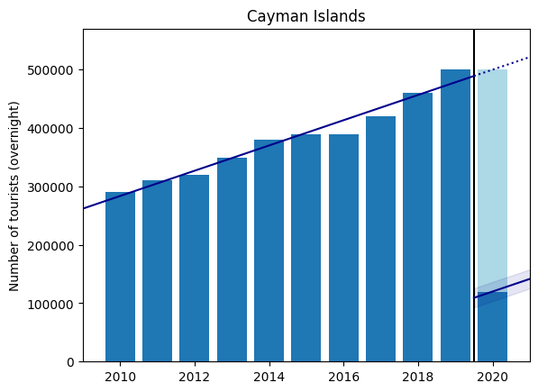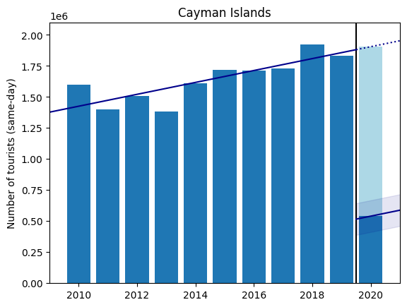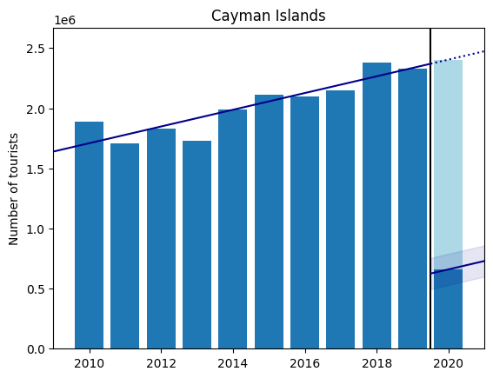

Figure 18: Economic impact of COVID-19 in the Cayman Islands on inbound tourism volume (total, overnight and same-day); dark blue bars are observed data, light blue represents predicted loss from COVID-19; trendline for pre-pandemic years with estimated pandemic effect including 95% confidence band

## Cuba

Table 10 and Figure 19 show the results for Cuba. Notably, the plots indicate that there is a substantial decline in tourism spending on transportation to the island even in years prior to the pandemic. As a result, the estimate of the impact of COVID-19 on transport expenditure is difficult to estimate and thus has a much wider confidence interval (see Table 10, Equation 1).

Moreover, we estimate a significant increase in the elasticity in COVID-19 mortality rates with respect to all economic variables; however, the graphs are not suggestive of an economic recovery. Instead, we formulate that Cuba has experienced a much larger COVID-19 spike in 2021 that, while it was perceived by tourists as less disruptive on a per-COVID-19 statistic increase, still had major negative consequences for the Cuban economy.

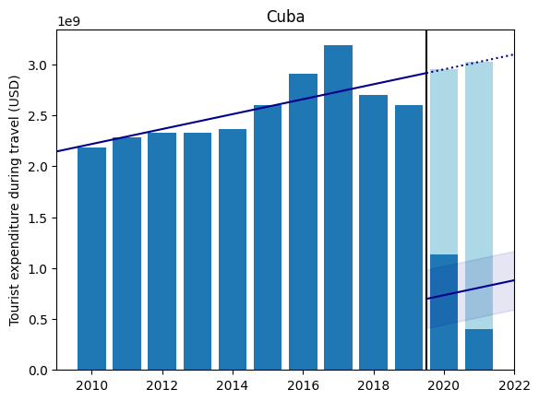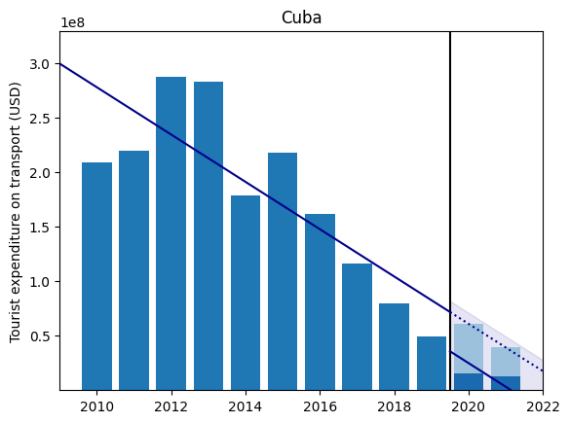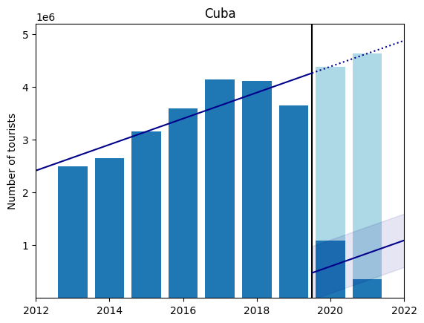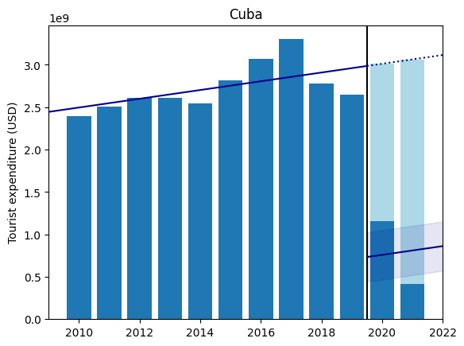

Figure 19: Economic impact of COVID-19 in Cuba on inbound tourism volume (total) and spending (total, travel and transport); dark blue bars are observed data, light blue represents predicted loss from COVID-19; trendline for pre-pandemic years with estimated pandemic effect including 95% confidence band

|  |  |  |  |  |  |  |  |
| --- | --- | --- | --- | --- | --- | --- | --- |
| Cuba | | | | | | | |
| $$Y_{t}$$ | (1) | (2) | | | | | |
| Estimated COVID-19 Impact | $x_{t}=$ COVID-19 cases | | $x_{t}=$ COVID-19 deaths | | $x_{t}=$ COVID-19 mortality | |
| 2020 | 2021 | 2020 | 2021 | 2020 | 2021 |
| Tourism Volume  (Total) | -3,786,111 (±506,121) | -.0001* | .0001* | -.0099* | .0096* | -117.97* | -191.02* |
| Tourism Spending  (Total) | -2.25×109 (±0.29×109) | -.0001* | .0001* | -.0066* | .0064* | -78.89* | -155.40* |
| Tourism Spending  (Travel) | -2.22×109 (±0.29×109) | -.0001* | .0001* | -.0066* | .0064* | -78.74* | -158.69* |
| Tourism Spending  (Transport) | -3.61×107 (±4.62×107) | -.0001* | .0001* | -.0102* | .0100* | -121.32* | -51.12 |

Table 10: OLS results for Cuba; estimated COVID-19 impact from Equation 1 includes 95% confidence interval in parenthesis; estimates for Equation 2 include p-values (*: p<.05; +: .05<p<.1)

Curaçao

|  |  |  |  |  |  |  |  |
| --- | --- | --- | --- | --- | --- | --- | --- |
| Curaçao | | | | | | | |
| $$Y_{t}$$ | (1) | (2) | | | | | |
| Estimated COVID-19 Impact | $x_{t}=$ COVID-19 cases | | $x_{t}=$ COVID-19 deaths | | $x_{t}=$ COVID-19 mortality | |
| 2020 | 2021 | 2020 | 2021 | 2020 | 2021 |
| Tourism Volume  (Total) | -851,062 (±103,959) | -.0003* | N/A | -.0789* | N/A | -336.24* | N/A |
| Tourism Volume  (Overnight) | -258,063 (±33,675) | -.0002* | .0002* | -.0713* | .0678* | -303.63* | 244.51* |
| Tourism Volume  (Same-day) | -555,666 (±94,163) | -.0003* | N/A | -.0837* | N/A | -356.35* | N/A |
| Tourism Spending  (Total) | -3.51×108 (±1.18×108) | -.0002* | .0002* | -.0669* | .0642* | -284.94* | 239.25* |
| Tourism Spending  (Travel) | -3.37×108 (±0.68×108) | -.0002* | .0002* | -.066* | .0633* | -281.25* | 234.67* |
| Tourism Spending  (Transport) | -1.33×107 (±5.9×107) | -.0005 | .0004 | -.154 | .1435 | -656.1* | 477.24* |

Table 11: OLS results for Curaçao; estimated COVID-19 impact from Equation 1 includes 95% confidence interval in parenthesis; estimates for Equation 2 include p-values (*: p<.05; +: .05<p<.1)

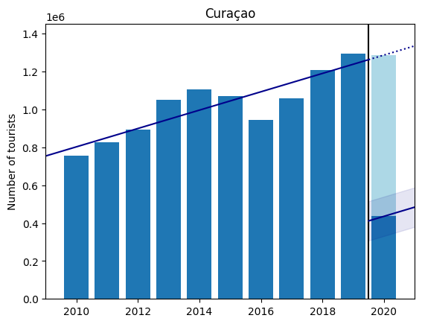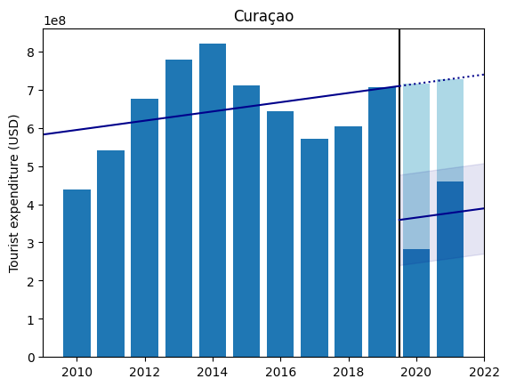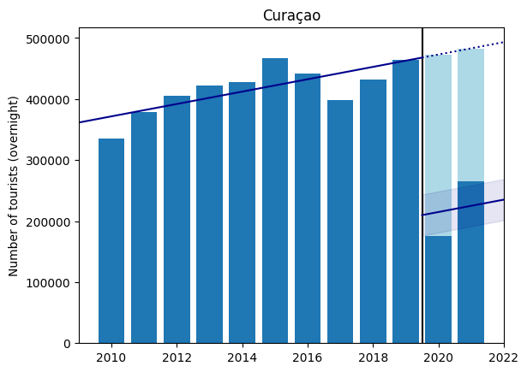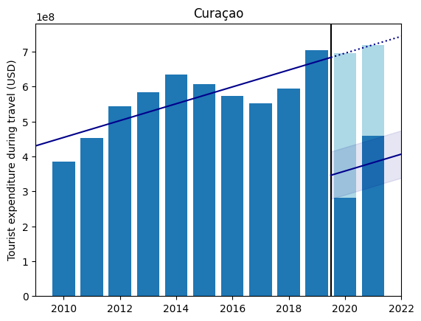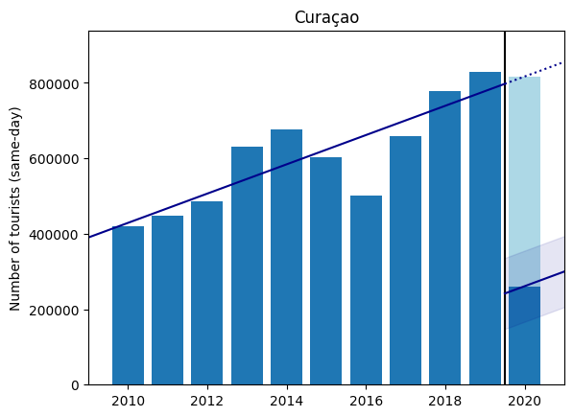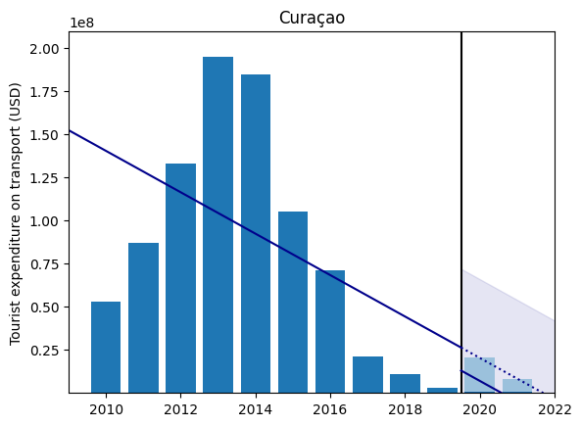

Figure 20: Economic impact of COVID-19 in Curaçao on inbound tourism volume (total, overnight and same-day) and spending (total, travel and transport); dark blue bars are observed data, light blue represents predicted loss from COVID-19; trendline for pre-pandemic years with estimated pandemic effect including 95% confidence band

Table 11 and Figure 20 show the results for Curaçao. As for Cuba, there is a substantial drop in tourism spending on transportation in the last few years preceding the pandemic. Consequently, the impact from COVID-19 (see Table 11, Equation 1) is uncertain on this economic variable since it was already following a substantial downward direction.

## Dominica

See footnote 12 for interpretation details of results in Table 12 and Figure 21.

|  |  |  |  |  |  |  |  |
| --- | --- | --- | --- | --- | --- | --- | --- |
| Dominica | | | | | | | |
| $$Y_{t}$$ | (1) | (2) | | | | | |
| Estimated COVID-19 Impact | $x_{t}=$ COVID-19 cases | | $x_{t}=$ COVID-19 deaths | | $x_{t}=$ COVID-19 mortality | |
| 2020 | 2021 | 2020 | 2021 | 2020 | 2021 |
| Tourism Volume  (Total) | -92392 ± 72685 | -.0053+ | .0051* | -.0108* | N/A | -72.59* | N/A |
| Tourism Spending  (Total) | -8.49×107 (±1.98×107) | -.0177* | .0174* | -.0135 | N/A | -90.52 | N/A |

Table 12: OLS results for Dominica; estimated COVID-19 impact from Equation 1 includes 95% confidence interval in parenthesis; estimates for Equation 2 include p-values (*: p<.05; +: .05<p<.1)

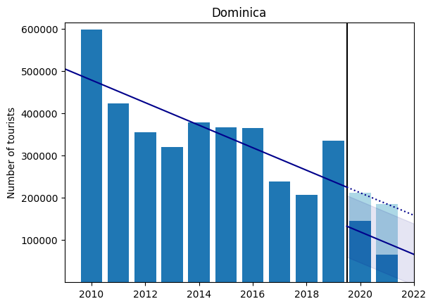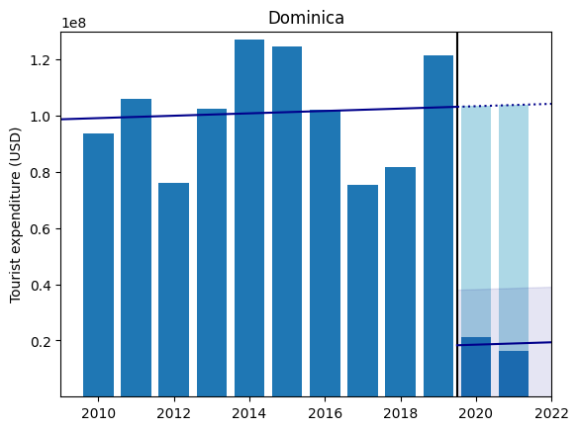

Figure 21: Economic impact of COVID-19 in Dominica on inbound tourism volume (total) and spending (total); dark blue bars are observed data, light blue represents predicted loss from COVID-19; trendline for pre-pandemic years with estimated pandemic effect including 95% confidence band

## Dominican Republic

Table 13 and Figure 22 show the results for the Dominican Republic.

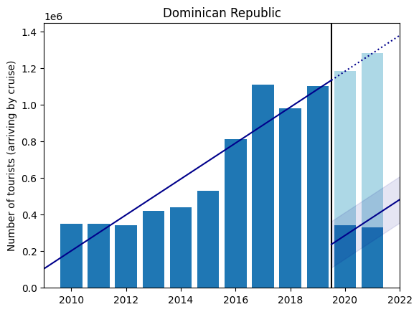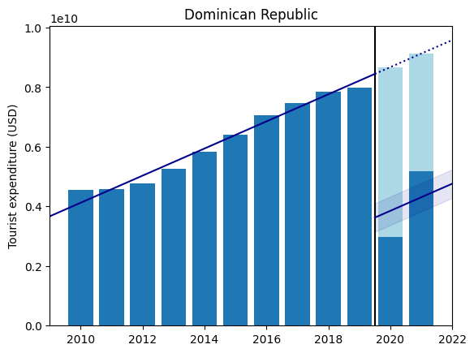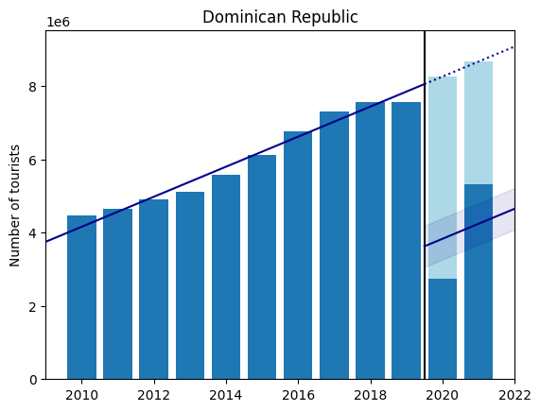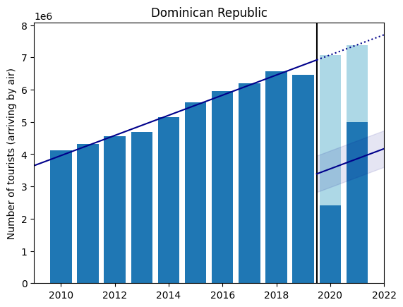

Figure 22: Economic impact of COVID-19 in the Dominican Republic on inbound tourism volume (total, air and cruise) and spending (total); dark blue bars are observed data, light blue represents predicted loss from COVID-19; trendline for pre-pandemic years with estimated pandemic effect including 95% confidence band

|  |  |  |  |  |  |  |  |
| --- | --- | --- | --- | --- | --- | --- | --- |
| Dominican Republic | | | | | | | |
| $$Y_{t}$$ | (1) | (2) | | | | | |
| Estimated COVID-19 Impact | $x_{t}=$ COVID-19 cases | | $x_{t}=$ COVID-19 deaths | | $x_{t}=$ COVID-19 mortality | |
| 2020 | 2021 | 2020 | 2021 | 2020 | 2021 |
| Tourism Volume  (Total) | -4,426,638 (±564,465) | 0<.0001* | 0<.0001* | -.0005* | .0002* | -79.89* | 7.35 |
| Tourism Volume  (Air) | -3,530,927 (±565,619) | 0<.0001* | 0<.0001* | -.0005* | .0002* | -77.57* | 20.06* |
| Tourism Volume  (Cruise) | -895,710 (±126,496) | 0<.0001* | 0<.0001* | -.0006* | .0003* | -97.52* | -113.99* |
| Tourism Spending  (Travel) | -4.82×109 (±0.48×108) | 0<.0001* | 0<.0001* | -.0005* | .0001* | -78.6* | -6.1 |

Table 13: OLS results for the Dominican Republic; estimated COVID-19 impact from Equation 1 includes 95% confidence interval in parenthesis; estimates for Equation 2 include p-values (*: p<.05; +: .05<p<.1)

## Grenada

See footnote 14 for interpretation details of results in Table 14 and Figure 23.

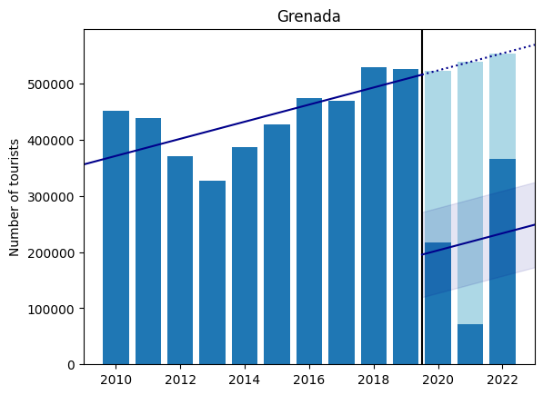

Figure 23: Economic impact of COVID-19 in Grenada on inbound tourism volume (total); dark blue bars are observed data, light blue represents predicted loss from COVID-19; trendline for pre-pandemic years with estimated pandemic effect including 95% confidence band

|  |  |  |  |  |  |  |  |  |  |  |
| --- | --- | --- | --- | --- | --- | --- | --- | --- | --- | --- |
| Grenada | | | | | | | | | | |
| $$Y_{t}$$ | (1) | (2) | | | | | | | | |
| Estimated COVID-19 Impact | $x_{t}=$ COVID-19 cases | | | $x_{t}=$ COVID-19 deaths | | | $x_{t}=$ COVID-19 mortality | | |
| 2020 | 2021 | 2022 | Avg. | 2021 | 2022 | Avg. | 2021 | 2022 |
| Tourism Volume  (Total) | -320,575 (±75,815) | -.0068* | .0065* | .0068* | -.0032 | -.0052+ | -.0019 | -22.83 | -28.22 | 5.39 |

Table 14: OLS results for Grenada; estimated COVID-19 impact from Equation 1 includes 95% confidence interval in parenthesis; estimates for Equation 2 include p-values (*: p<.05; +: .05<p<.1)

## Haiti

Table 15 and Figure 24 show the results for Haiti.

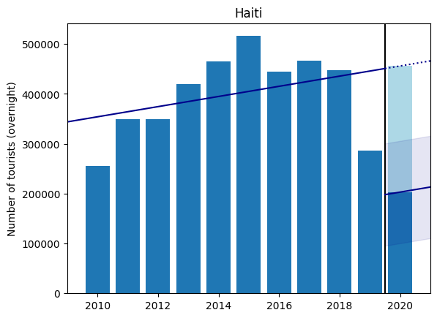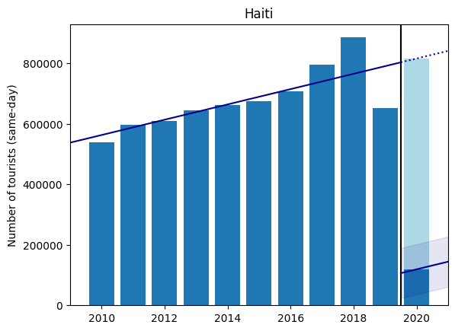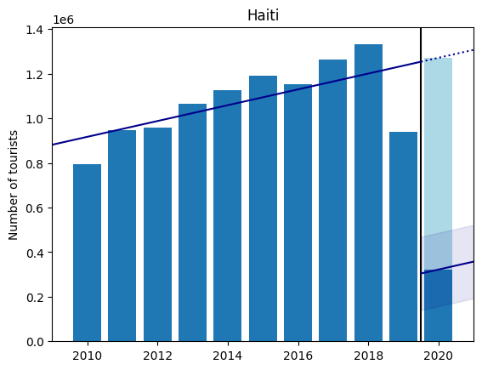

Figure 24: Economic impact of COVID-19 in Haiti on inbound tourism volume (total, overnight and same-day); dark blue bars are observed data, light blue represents predicted loss from COVID-19; trendline for pre-pandemic years with estimated pandemic effect including 95% confidence band

|  |  |  |  |  |
| --- | --- | --- | --- | --- |
| Haiti | | | | |
| $$Y_{t}$$ | (1) | (2) | | |
| Estimated COVID-19 Impact | $x_{t}=$ COVID-19 cases | $x_{t}=$ COVID-19 deaths | $x_{t}=$ COVID-19 mortality |
| 2020 | 2020 | 2020 |
| Tourism Volume  (Total) | -949,466 (±164,581) | -.0001* | -.0059* | -58.53* |
| Tourism Volume  (Overnight) | -252,933 (±102,640) | -.0001* | -.0034* | -34.11* |
| Tourism Volume  (Same-day) | -696,533 (±83,010) | -.0002* | -.0082* | -81.87* |

Table 15: OLS results for Haiti; estimated COVID-19 impact from Equation 1 includes 95% confidence interval in parenthesis; estimates for Equation 2 include p-values (*: p<.05; +: .05<p<.1)

## Jamaica

Table 16 and Figure 25 show the results for Jamaica.

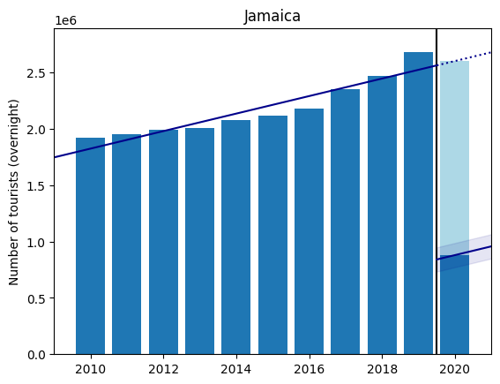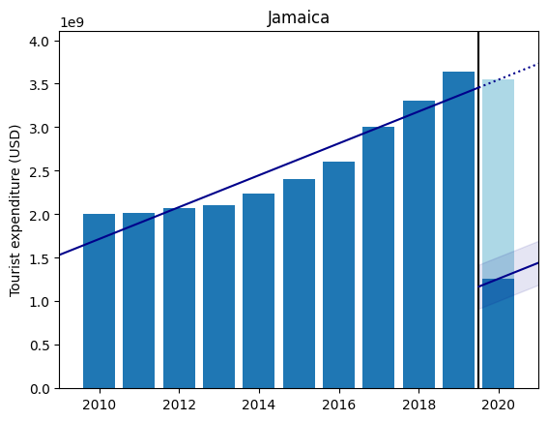

Figure 25: Economic impact of COVID-19 in Jamaica on inbound tourism volume (overnight) and spending (total); dark blue bars are observed data, light blue represents predicted loss from COVID-19; trendline for pre-pandemic years with estimated pandemic effect including 95% confidence band

|  |  |  |  |  |
| --- | --- | --- | --- | --- |
| Jamaica | | | | |
| $$Y_{t}$$ | (1) | (2) | | |
| Estimated COVID-19 Impact | $x_{t}=$ COVID-19 cases | $x_{t}=$ COVID-19 deaths | $x_{t}=$ COVID-19 mortality |
| 2020 | 2020 | 2020 |
| Tourism Volume  (Overnight) | -1,722,666 (±107,500) | -.0001* | -.0036* | -46.33* |
| Tourism Spending  (Total) | -2.29×109 (±0.25×109) | -.0001* | -.0035* | -45.05* |

Table 16: OLS results for Jamaica; estimated COVID-19 impact from Equation 1 includes 95% confidence interval in parenthesis; estimates for Equation 2 include p-values (*: p<.05; +: .05<p<.1)

## Martinique

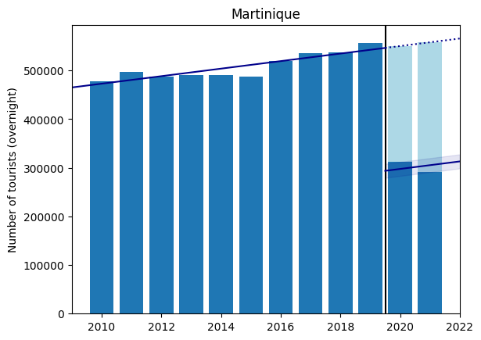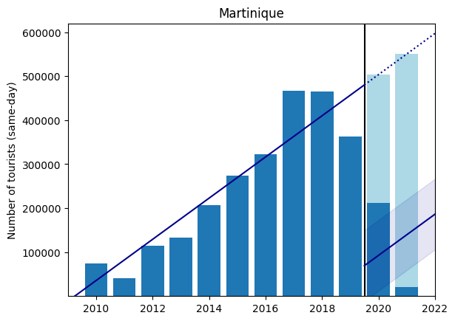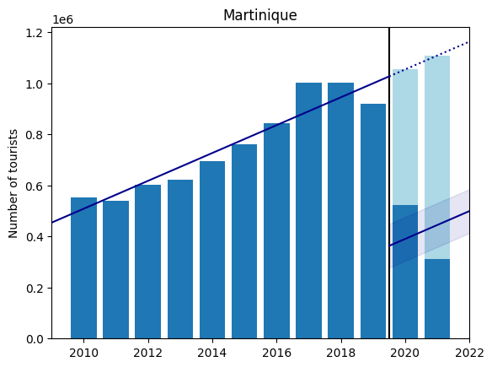

Figure 26: Economic impact of COVID-19 in Martinique on inbound tourism volume (total, overnight and same-day); dark blue bars are observed data, light blue represents predicted loss from COVID-19; trendline for pre-pandemic years with estimated pandemic effect including 95% confidence band

|  |  |  |  |  |  |  |  |
| --- | --- | --- | --- | --- | --- | --- | --- |
| Martinique | | | | | | | |
| $$Y_{t}$$ | (1) | (2) | | | | | |
| Estimated COVID-19 Impact | $x_{t}=$ COVID-19 cases | | $x_{t}=$ COVID-19 deaths | | $x_{t}=$ COVID-19 mortality | |
| 2020 | 2021 | 2020 | 2021 | 2020 | 2021 |
| Tourism Volume  (Total) | -663,716 (±85,944) | -.0001* | .0001* | -.018* | .0162* | -109.26* | -32.15* |
| Tourism Volume  (Overnight) | -252,745 (±14,404) | -.0001* | .0001* | -.0136* | .0127* | -82.47* | 44.97* |
| Tourism Volume  (Same-day) | -410,971 (±80,413) | -.0002* | .0001 | -.0304* | .0252* | -184.54* | -34.77 |

Table 17: OLS results for Martinique; estimated COVID-19 impact from Equation 1 includes 95% confidence interval in parenthesis; estimates for Equation 2 include p-values (*: p<.05; +: .05<p<.1)

## Montserrat

See footnote 13 for interpretation details of results. We observe in Table 18 and Figure 27 that the Montserrat economy experienced substantially more hardship from COVID-19 cases relative to other Caribbean countries and showed no statistically significant indication of recovery in the year 2021.

|  |  |  |  |  |  |  |  |
| --- | --- | --- | --- | --- | --- | --- | --- |
| Montserrat | | | | | | | |
| $$Y_{t}$$ | (1) | (2) | | | | | |
| Estimated COVID-19 Impact | $x_{t}=$ COVID-19 cases | | $x_{t}=$ COVID-19 deaths | | $x_{t}=$ COVID-19 mortality | |
| 2020 | 2021 | 2020 | 2021 | 2020 | 2021 |
| Tourism Volume  (Total) | -16,900 (±2,284) | -.0775* | -.0056 | -.0101 | N/A | -1.3 | N/A |
| Tourism Spending  (Total) | -7.53×106 (±1.06×106) | -.0611* | -.0003 | -.1236* | N/A | -1.61* | N/A |

Table 18: OLS results for Montserrat; estimated COVID-19 impact from Equation 1 includes 95% confidence interval in parenthesis; estimates for Equation 2 include p-values (*: p<.05; +: .05<p<.1)

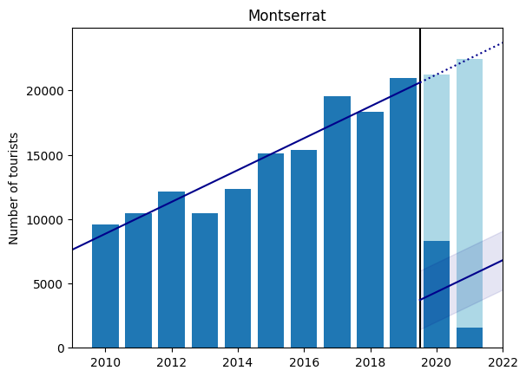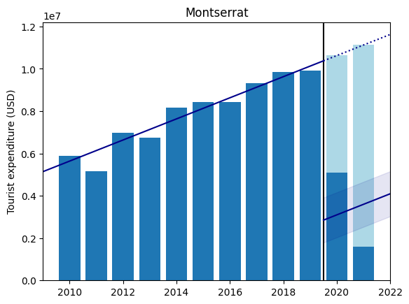

Figure 27: Economic impact of COVID-19 in Montserrat on inbound tourism volume (total) and spending (total); dark blue bars are observed data, light blue represents predicted loss from COVID-19; trendline for pre-pandemic years with estimated pandemic effect including 95% confidence band

## Puerto Rico

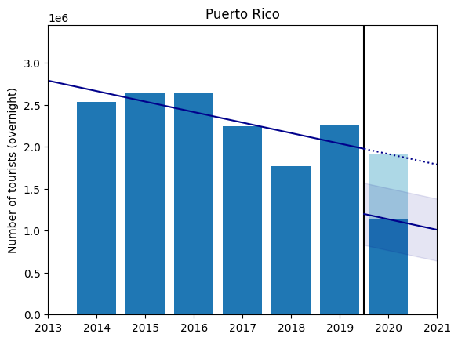

Figure 28: Economic impact of COVID-19 in Puerto Rico on inbound tourism volume (overnight); dark blue bars are observed data, light blue represents predicted loss from COVID-19; trendline for pre-pandemic years with estimated pandemic effect including 95% confidence band

|  |  |  |  |  |
| --- | --- | --- | --- | --- |
| Puerto Rico | | | | |
| $$Y_{t}$$ | (1) | (2) | | |
| Estimated COVID-19 Impact | $x_{t}=$ COVID-19 cases | $x_{t}=$ COVID-19 deaths | $x_{t}=$ COVID-19 mortality |
| 2020 | 2020 | 2020 |
| Tourism Volume  (Overnight) | -777,406 (±369,820) | 0<.0001* | -.0003* | -26.62* |

Table 19: OLS results for Puerto Rico; estimated COVID-19 impact from Equation 1 includes 95% confidence interval in parenthesis; estimates for Equation 2 include p-values (*: p<.05; +: .05<p<.1)

## St. Kitts and Nevis

See footnote 12 for interpretation details of results.

|  |  |  |  |  |  |  |  |
| --- | --- | --- | --- | --- | --- | --- | --- |
| St. Kitts and Nevis | | | | | | | |
| $$Y_{t}$$ | (1) | (2) | | | | | |
| Estimated COVID-19 Impact | $x_{t}=$ COVID-19 cases | | $x_{t}=$ COVID-19 deaths | | $x_{t}=$ COVID-19 mortality | |
| 2020 | 2021 | 2020 | 2021 | 2020 | 2021 |
| Tourism Volume  (Total) | -1,183,921 (±102,003) | -.0492* | .0483* | -.0335* | N/A | -105.28* | N/A |
| Tourism Spending  (Total) | -1.65×108 (±0.12×108) | -.0473* | .0467* | -.027* | N/A | -80.19* | N/A |

Table 20: OLS results for St. Kitts and Nevis; estimated COVID-19 impact from Equation 1 includes 95% confidence interval in parenthesis; estimates for Equation 2 include p-values (*: p<.05; +: .05<p<.1)

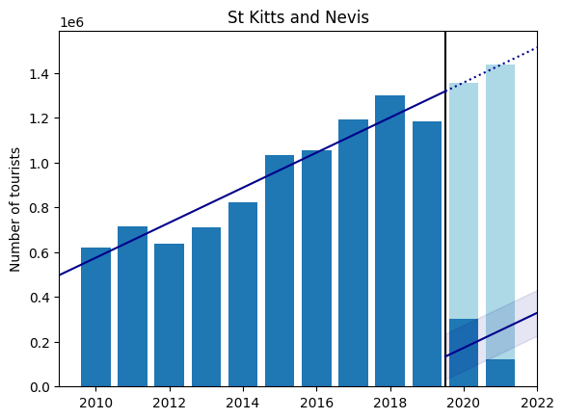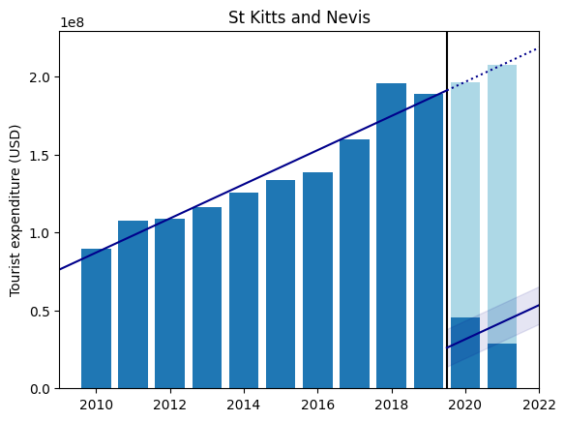

Figure 29: Economic impact of COVID-19 in St. Kitts and Nevis on inbound tourism volume (total) and spending (total); dark blue bars are observed data, light blue represents predicted loss from COVID-19; trendline for pre-pandemic years with estimated pandemic effect including 95% confidence band

## St. Lucia

|  |  |  |  |  |  |  |  |
| --- | --- | --- | --- | --- | --- | --- | --- |
| St. Lucia | | | | | | | |
| $$Y_{t}$$ | (1) | (2) | | | | | |
| Estimated COVID-19 Impact | $x_{t}=$ COVID-19 cases | | $x_{t}=$ COVID-19 deaths | | $x_{t}=$ COVID-19 mortality | |
| 2020 | 2021 | 2020 | 2021 | 2020 | 2021 |
| Tourism Volume  (Total) | -866,235 (±81,158) | -.0028* | .0027* | -.1999* | .1949* | -70.55* | 4.97 |
| Tourism Spending  (Total) | -4.8×108 (±1.05×108) | -.0033* | .0033* | -.2331* | .232* | -82.29* | 67.04* |

Table 21: OLS results for St. Lucia; estimated COVID-19 impact from Equation 1 includes 95% confidence interval in parenthesis; estimates for Equation 2 include p-values (*: p<.05; +: .05<p<.1)

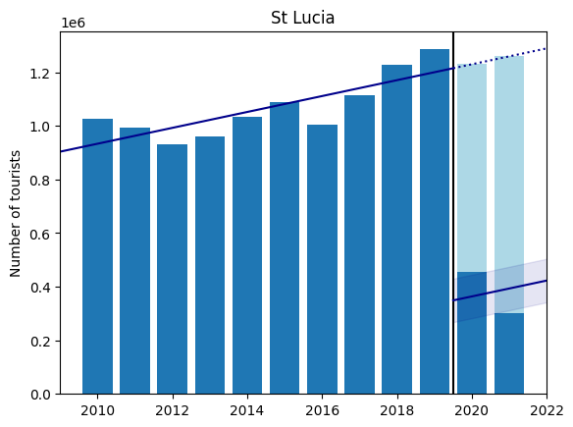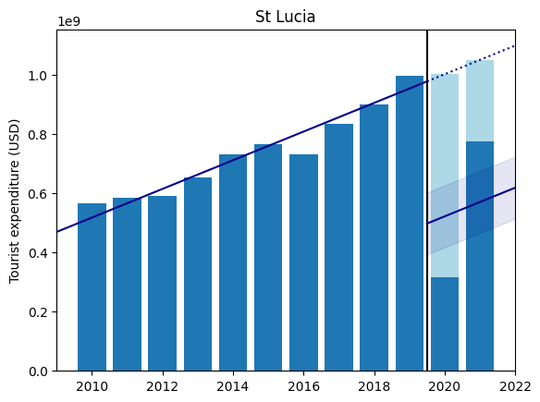

Figure 30: Economic impact of COVID-19 in St. Lucia on inbound tourism volume (total) and spending (total); dark blue bars are observed data, light blue represents predicted loss from COVID-19; trendline for pre-pandemic years with estimated pandemic effect including 95% confidence band

## St. Vincent and the Grenadines

See footnote 12 for interpretation details of results.

|  |  |  |  |  |  |  |  |
| --- | --- | --- | --- | --- | --- | --- | --- |
| St. Vincent and the Grenadines | | | | | | | |
| $$Y_{t}$$ | (1) | (2) | | | | | |
| Estimated COVID-19 Impact | $x_{t}=$ COVID-19 cases | | $x_{t}=$ COVID-19 deaths | | $x_{t}=$ COVID-19 mortality | |
| 2020 | 2021 | 2020 | 2021 | 2020 | 2021 |
| Tourism Volume  (Total) | -259,309 (±54,251) | -.0069* | .0066* | -.0099* | N/A | -56.66* | N/A |
| Tourism Spending  (Total) | -7.13×107 (±0.54×107) | -.0077* | .0075* | -.0049* | N/A | -28.35* | N/A |

Table 22: OLS results for St. Vincent and the Grenadines; estimated COVID-19 impact from Equation 1 includes 95% confidence interval in parenthesis; estimates for Equation 2 include p-values (*: p<.05; +: .05<p<.1)

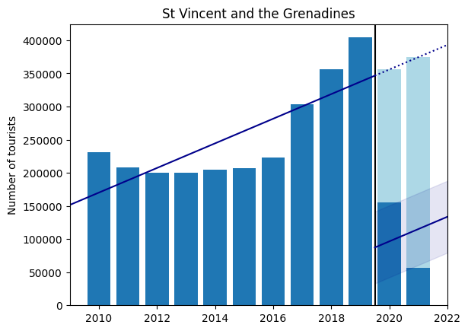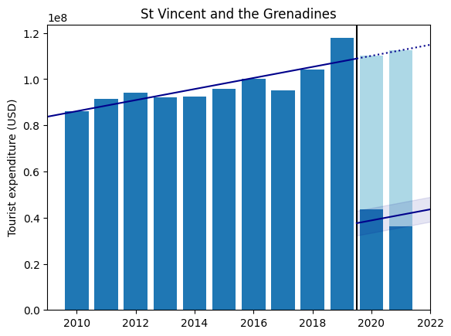

Figure 31: Economic impact of COVID-19 in St. Vincent and the Grenadines on inbound tourism volume (total) and spending (total); dark blue bars are observed data, light blue represents predicted loss from COVID-19; trendline for pre-pandemic years with estimated pandemic effect including 95% confidence band

## St. Maarten

|  |  |  |  |  |  |  |  |
| --- | --- | --- | --- | --- | --- | --- | --- |
| St. Maarten | | | | | | | |
| $$Y_{t}$$ | (1) | (2) | | | | | |
| Estimated COVID-19 Impact | $x_{t}=$ COVID-19 cases | | $x_{t}=$ COVID-19 deaths | | $x_{t}=$ COVID-19 mortality | |
| 2020 | 2021 | 2020 | 2021 | 2020 | 2021 |
| Tourism Volume  (Cruise) | -1,092,669 (±216,712) | -.0008* | .0004* | -.0448* | .0081 | -65.22* | -72.02 |

Table 23: OLS results for St. Maarten; estimated COVID-19 impact from Equation 1 includes 95% confidence interval in parenthesis; estimates for Equation 2 include p-values (*: p<.05; +: .05<p<.1)

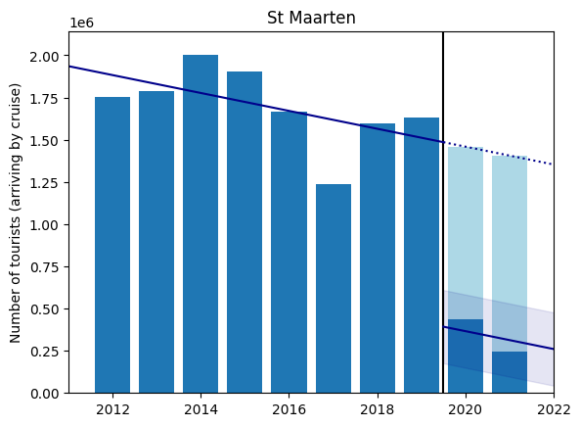

Figure 32: Economic impact of COVID-19 in St. Maarten on inbound tourism volume (cruise); dark blue bars are observed data, light blue represents predicted loss from COVID-19; trendline for pre-pandemic years with estimated pandemic effect including 95% confidence band

The data in Table 23 and Figure 32 indicate that tourist cruise arrivals have been declining in the years prior to the pandemic and the onset of COVID-19 merely accelerated this decreasing trend.

Trinidad and Tobago

|  |  |  |  |  |  |  |  |
| --- | --- | --- | --- | --- | --- | --- | --- |
| Trinidad and Tobago | | | | | | | |
| $$Y_{t}$$ | (1) | (2) | | | | | |
| Estimated COVID-19 Impact | $x_{t}=$ COVID-19 cases | | $x_{t}=$ COVID-19 deaths | | $x_{t}=$ COVID-19 mortality | |
| 2020 | 2021 | 2020 | 2021 | 2020 | 2021 |
| Tourism Volume  (Total) | -342,866 (±25,312) | -.0002* | N/A | -.0097* | N/A | -69.37* | N/A |
| Tourism Volume  (Overnight) | -293,466 (±29,130) | -.0002* | N/A | -.0111* | N/A | -79.28* | N/A |
| Tourism Volume  (Same-day) | -49,400 (±33,343) | -.0001 | N/A | -.0056 | N/A | -39.83 | N/A |
| Tourism Spending  (Total) | -4.84×108 (±1.27×108) | -.0002* | .0002* | -.0106* | .0098* | -76.11* | 6.57 |
| Tourism Spending  (Travel) | -3.48×108 (±0.39×108) | -.0002* | .0001* | -.009* | .0082* | -64.17* | -0.79 |
| Tourism Spending  (Transport) | -1.35×108 (±1.26×108) | -.0004* | .0003* | -.0206* | .0196* | -147.59* | 55.85 |

Table 24: OLS results for Trinidad and Tobago; estimated COVID-19 impact from Equation 1 includes 95% confidence interval in parenthesis; estimates for Equation 2 include p-values (*: p<.05; +: .05<p<.1)

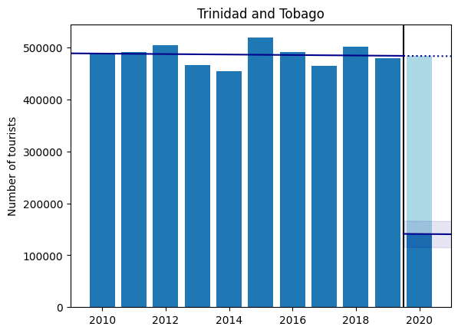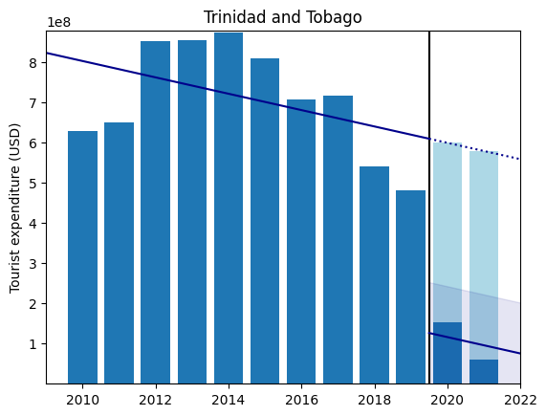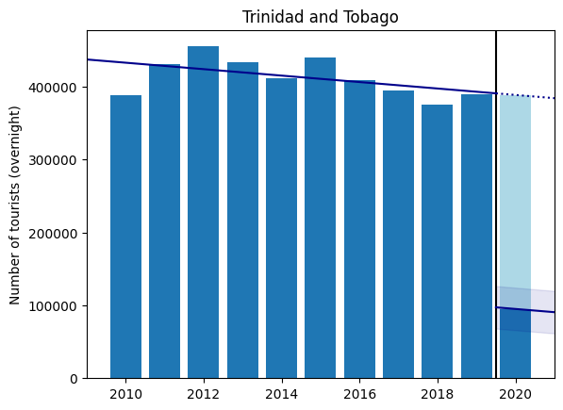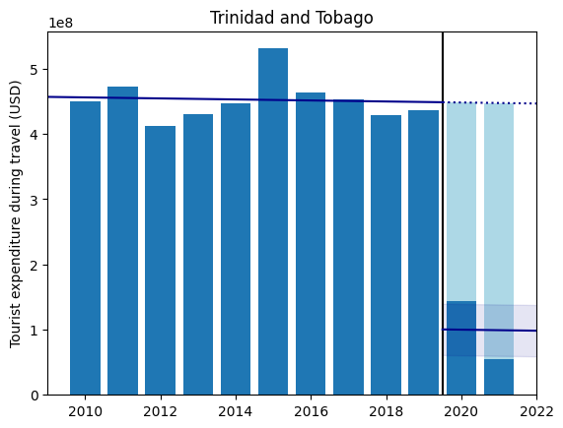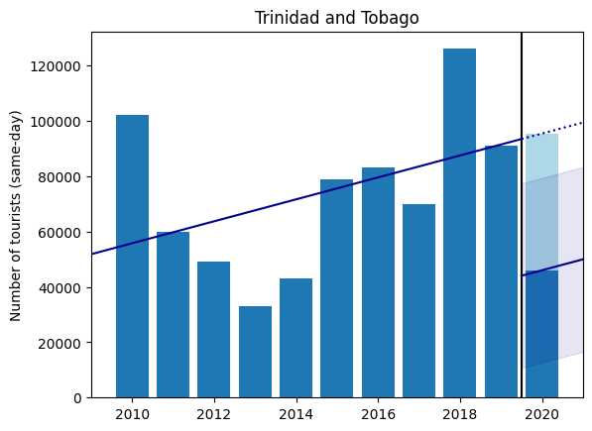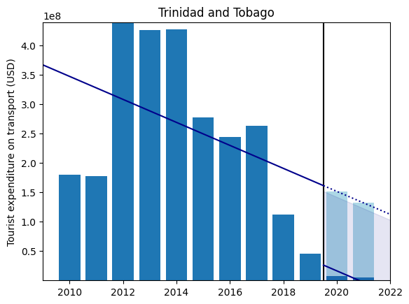

Figure 33: Economic impact of COVID-19 in Trinidad and Tobago on inbound tourism volume (total, overnight and same-day) and spending (total, travel and transport); dark blue bars are observed data, light blue represents predicted loss from COVID-19; trendline for pre-pandemic years with estimated pandemic effect including 95% confidence band

## Turks and Caicos

|  |  |  |  |  |  |  |  |
| --- | --- | --- | --- | --- | --- | --- | --- |
| Turks and Caicos | | | | | | | |
| $$Y_{t}$$ | (1) | (2) | | | | | |
| Estimated COVID-19 Impact | $x_{t}=$ COVID-19 cases | | $x_{t}=$ COVID-19 deaths | | $x_{t}=$ COVID-19 mortality | |
| 2020 | 2021 | 2020 | 2021 | 2020 | 2021 |
| Tourism Volume  (Total) | -1,237,108 (±85,120) | -.0017* | .0011* | -.2493* | .1792 | -222.66* | 54.84 |

Table 25: OLS results for Turks and Caicos; estimated COVID-19 impact from Equation 1 includes 95% confidence interval in parenthesis; estimates for Equation 2 include p-values (*: p<.05; +: .05<p<.1)

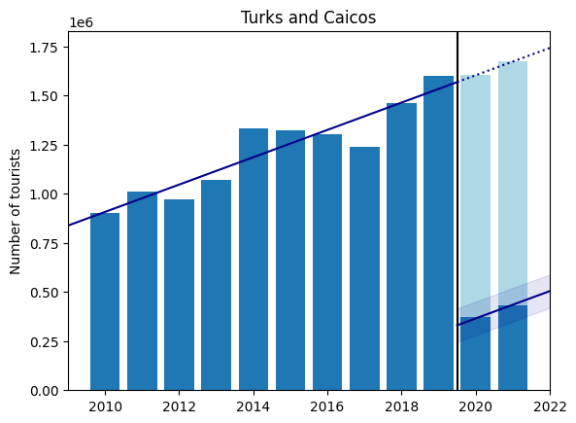

Figure 34: Economic impact of COVID-19 in Turks and Caicos on inbound tourism volume (total); dark blue bars are observed data, light blue represents predicted loss from COVID-19; trendline for pre-pandemic years with estimated pandemic effect including 95% confidence band

## U.S. Virgin Islands

|  |  |  |  |  |
| --- | --- | --- | --- | --- |
| U.S. Virgin Islands | | | | |
| $$Y_{t}$$ | (1) | (2) | | |
| Estimated COVID-19 Impact | $x_{t}=$ COVID-19 cases | $x_{t}=$ COVID-19 deaths | $x_{t}=$ COVID-19 mortality |
| 2020 | 2020 | 2020 |
| Tourism Volume  (Total) | -1.14×109 (±0.29×109) | -.0354* | -.0366* | -74.55* |

Table 26: OLS results for the U.S. Virgin Islands; estimated COVID-19 impact from Equation 1 includes 95% confidence interval in parenthesis; estimates for Equation 2 include p-values (*: p<.05; +: .05<p<.1)

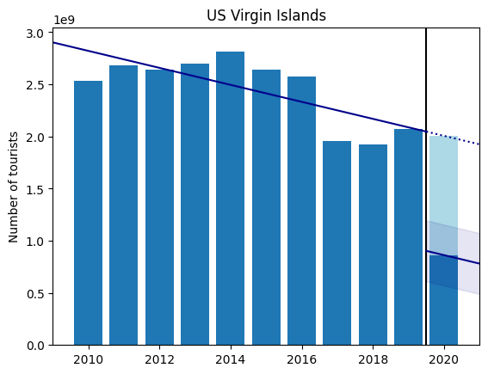

Figure 35: Economic impact of COVID-19 in the U.S. Virgin Islands on inbound tourism volume (total); dark blue bars are observed data, light blue represents predicted loss from COVID-19; trendline for pre-pandemic years with estimated pandemic effect including 95% confidence band

# Section IV. Caribbean Panel Data Analysis

This final section presents the econometric analysis conducted across all of the selected countries and their available data to understand the overall impact of COVID-19 cases, deaths and mortality rates on the Caribbean economy. Each of the twenty-four countries contain data points for varying economic data and different number of periods, ranging from the year 2010 to 202, depending on information availability; consequently, the collective dataset represents an unbalanced panel data.

In order to analyze the effects of the COVID-19 variables on the economic metrics across the level of the entire Caribbean region, we use a fixed-effects model controlling for entity effects—for the scope of this project, the term “entity” refers to the individual countries in the Caribbean dataset whereas “entity effects” specify per-country unobservable effects that remain constant through time but vary across entities, capturing individual characteristics that can influence the coefficient estimates of the OLS regression. Therefore, using a fixed-effects method of analysis removes per-country biases and focuses the model on the impact of COVID-19 variables on the chosen economic metrics.

The fixed-effects log-level model used for statistical analysis is as follows:

|  |  |  |
| --- | --- | --- |
|  | $$\log{Y_{i,t}}=β_{0}+α_{i}+β_{1}x_{i,t}$$ | (3) |

Index $i$ indicates the country and subscript $t$ specifies the year for each data point. As in Section III and Equations 1 and 2, $Y_{i,t}$ is the economic dependent variable of interest—e.g., total inbound tourist volume, spending, etc.—and $x_{i,t}$ is the regressor—i.e., COVID-19 cases, deaths or mortality rate. $α_{i}$ is the per-country average effect across the given period of time, which is accounted for and eliminated from the regression through demeaning of the data. Thus, the coefficient estimate $β_{1}$ represents the average marginal effect of the COVID-19 variable on the economic metric: a one-unit increase in the regressor $x$ is associated with an average ${100⋅β}_{1}$ percent increase in the dependent variable $Y$.

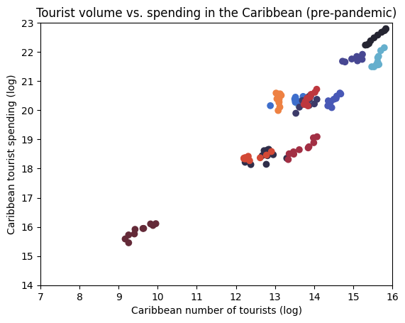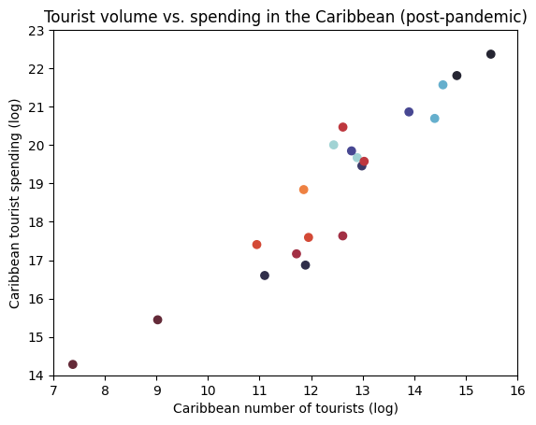

Figure 36: Log-log plots of total tourist volume and spending in the Caribbean

First, we examine the relationship between different variables of interest in the Caribbean region. Figure 36 illustrates the distribution of number of tourists and expenditure across countries, each entity being represented with a unique color, split into two graphs for the pre- and post-pandemic time periods. On the left plot, we observe a clear separation across Caribbean countries for both tourist volume and spending forming visually distinct clusters of data. On the right side, this characteristic is less predominant due to the lack of data—each point is recorded in 2020, 2021 or 2022—and entity-varying magnitude of economic reduction from COVID-19.

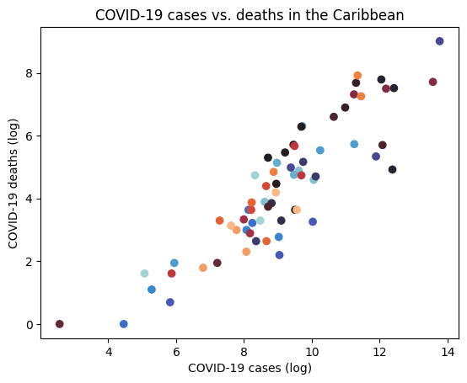

Figure 37: Log-log plot of COVID-19 cases vs. deaths in the Caribbean

[TBD] present the results from the fixed-effects regression.

|  |  |  |  |  |
| --- | --- | --- | --- | --- |
| Caribbean Panel Data | | | | |
| $$Y_{t}$$ | (3) | | | |
| No. Obs. | $x_{t}=$ COVID-19 cases | $x_{t}=$ COVID-19 deaths | $x_{t}=$ COVID-19 mortality |
| Tourism Volume  (Total) |  | -.0354* | -.0366* | -74.55* |
| Tourism Volume  (Overnight) |  |  |  |  |

## Addendum: Economic Impact of COVID-19 on Caribbean Countries

[TBD]



Figure 38: Impact of the COVID-19 pandemic on the total inbound tourist volume for Caribbean countries; dark blue bars are observed data, light blue represents predicted loss from COVID-19; trendline for pre-pandemic years with estimated pandemic effect including 95% confidence band

1. <https://www.imf.org/en/Publications/fandd/issues/2020/12/impact-of-the-pandemic-on-tourism-behsudi>
2. [https://jupyter.org](https://jupyter.org/)
3. [https://brew.sh](https://brew.sh/)
4. <https://matplotlib.org>
5. [https://numpy.org](https://numpy.org/)
6. [https://pandas.pydata.org](https://pandas.pydata.org/)
7. <https://www.statsmodels.org/stable/index.html>
8. [https://bashtage.github.io/linearmodels](https://bashtage.github.io/linearmodels/)
9. [https://seaborn.pydata.org](https://seaborn.pydata.org/)
10. [https://www.statista.com](https://www.statista.com/)
11. The exception to this rule occurs in the case of a zero-value in the post-pandemic data (i.e., for Dominica, Grenada, St. Kitts and Nevis, and St. Vincent and the Grenadines, the number of COVID-19 deaths and mortality rate is zero for the year 2020; and for Montserrat, in 2021; see Table 2). Consequently, the interpretation of the coefficients is further slightly altered; see additional footnotes 12, 13 and 14.
12. For Dominica, St. Kitts and Nevis, and St. Vincent and the Grenadines, the number of COVID-19 deaths and mortality are zero in 2020; consequently, $x_{t}$ and $x_{t}1_{t}(t=2021)$ are identical variables implying $β_{2}=β_{3}$, and so they both represent the effect of the pandemic in the year 2020.
13. For Montserrat, deaths and mortality are zero in 2021; thus, $x_{t}1_{t}(t=2021)$ is a null variable with zero variance and so its $β_{3}$ coefficient has no meaning with the interpretation of $β_{2}$ remaining as before.
14. For Grenada, deaths and mortality are zero in 2020; therefore, $β_{2}$ is the baseline average between years 2021 and 2022, and so $β_{3}$ and $β_{4}$ are the relative effects relative to this average impact.